Curriculum vitae

Dr. SREENIVASA B R
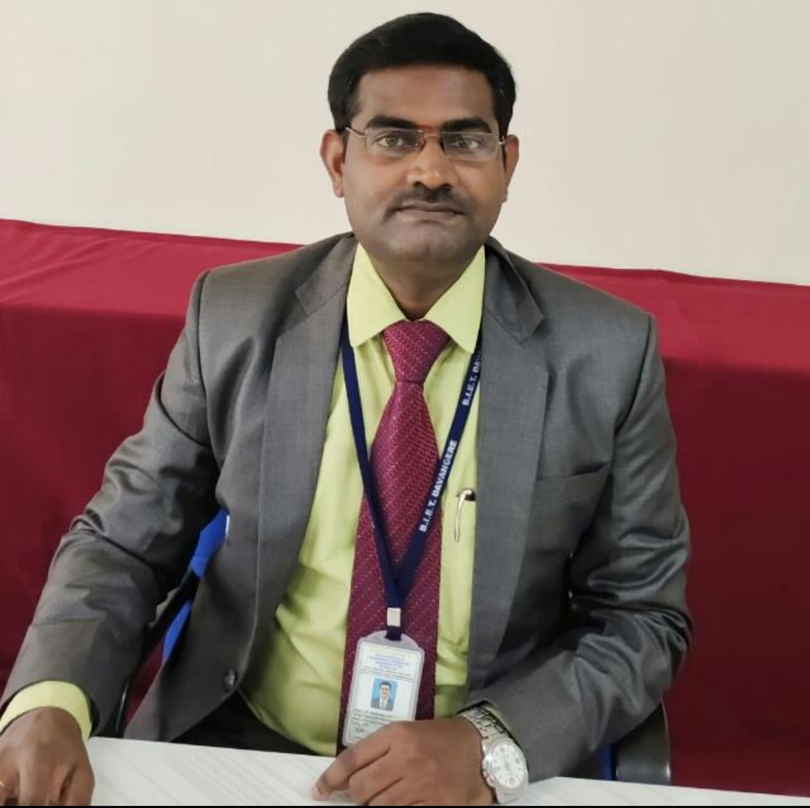
Professor,
Dept. of CS&D,
Bapuji Institute of Engineering & Technology,
Davangere-577004, Karnataka, India.
Mobile: +91 9844647541
E-mail: br.sreenu@gmail.com
sreenivasabr@bietdvg.edu

VISION STATEMENT

My dream career path would be to work at a research institution where teaching and research are deeply intertwined. I enjoy creating knowledge via continuous investigations in my research areas, but I equally value passing knowledge on to students and others because it teaches, inspires, and promotes personal and societal growth. As a member of the faculty, I wish to cultivate my own teaching and research identities, assist students' learning, and contribute to active collaboration among faculty members.
OBJECTIVES

- To provide outcome-based education to the students.
- To instill students with intrinsic motivation to learn.
- To instill Positive Action principles into students’ cognitive, affective, and behavioral learning domains.
- To contribute to the teaching and achieving of core performance standards and outcomes - To improve students’ behavior.
- Expand my research base by building relationships between the Faculty, the University, the community, and industry.
- Willing to accept challenges and Completion of tasks within the timeframe.
- Engaging in and providing chances for professional advancement and seeking and providing guidance to meet teaching, research, and career goals.
- To prepare our students for professional work and development in modern business, industry, and communities.

EDUCATIONAL QUALIFICATION

- Ph.D. in Computer Science & Engineering, Visvesvaraya Technological University, Belgaum, titled “Personalized Recommendations for e-Commerce Applications using Machine Learning Techniques”, completed in February 2021.
- M.Tech. in Computer Science and Engineering from University B.D.T College of Engineering, Davangere. (Affiliated to Davangere University, Davangere).
- B.E. in Computer Science and Engineering from Bapuji Institute of Engineering & Technology (Affiliated to Visvesvaraya Technological University, Belgaum, Karnataka).

AWARDS
- Received 1st prize of rupees 50k in national level Inter-Collegiate event Competition conducted by Sookshmas e-Learning Pvt. Ltd under my guidance.
- M.Tech topper in the Department.
- Best Innovative Teacher Award.
- Received a certificate of excellence for continuously achieving 100% results.
- Best Paper presentation award at International Conference ICICN-16.
PATENTS

- “Artificial Intelligence Based Internet-Of-Vehicles (IOV) System To Prevent Road Accidents”, Application Number 202141011709 Reference Number 202141011709, RQ Number-R20214009059, Filling Date 19/03/2021-Indian Patent Office.
- “Artificial Intelligence Based Antenna for 5g Technology”, Application Number 202241006221 A, Published Date: 11/02/2022.
RESEARCH INTEREST

- Currently supervising 6 students at VTU.
- My primary goal is to deepen and extend my research in multidisciplinary areas and promote industry-institute collaboration.
- I will seek to get grants from various funding agencies and publish my work in peer-reviewed journals.
- Interested in Post-Doctoral Degrees from Industry/Foreign Universities.
- Initiated writing book chapters and Books.
RESEARCH COLLABORATION

- Collaborated with King Abdulaziz University, Jeddah, Saudi Arabia.
- Collaborated with ICAR-Taralabalu Krishi Vigyan Kendra, Davangere.

TEACHING INTEREST

- I would like to encourage active learning in my classroom.
- To be actively involved in accreditation processes like NBA, NAAC, NIRF, and AICTE.
- Love to take on new challenging subjects introduced in the university curriculum.
- Continue to be attentive to the needs of our communities (the public, our profession, academia, our university, our faculty, our students, and business and industry, as well as the environment).
- Maintain a professional, ethical, and courteous workplace that is mutually supportive and welcoming of diversity and encourages communication, dialogue, and resource sharing whenever feasible.
- Passion for guiding students’ projects.
- Collaborate with Industry to cater myself to the changes and to bridge the gap between academia and industry.
- Imparting the knowledge to the students.

WORK EXPERIENCE:

Summary
Up to the present date (July 2024), I have a total work experience of 15 years in teaching, which
I enjoyed, learned, acquired immense satisfaction, and gained experience.
- July 2021-Till date, currently working as Associate Professor in Dept. of Information Science & Engineering, Bapuji Institute of Engineering & Technology, Davangere, Karnataka, India.
- June 2021-July 2021 Worked as Associate Professor in Dept. of Computer Science & Engineering, Jain Institute of Technology, Davangere, Karnataka, India.
- Feb 2017-June 2021 Worked as Assistant Professor in Dept. of Computer Science & Engineering, Jain Institute of Technology, Davangere, Karnataka, India.
- Aug 2010 – Feb 2017 Worked as Assistant Professor in Dept. of Computer Science & Engineering, RajaRajeswari College of Engineering, Bangalore, and Karnataka, India.

RESPONSIBILITIES UNDERTAKEN
- Staff Selection Committee Member at Bapuji Institute of Engineering & Technology.
- IQAC Coordinator at Bapuji Institute of Engineering & Technology.
- Worked as National Board of Accreditation (NBA) Coordinator at the college level at Bapuji Institute of Engineering & Technology (2021-till date) and Jain Institute of Technology, Davanagere. (2017-2022).
- Worked as National Board of Accreditation (NBA) Coordinator at the college level at Rajarajeswari College of Engineering, Bangalore. (2013-2017).
- Reviewer for Various Refereed International Journals.
- Worked as NAAC Coordinator at department level at Rajarajeswari College of Engineering, Bangalore. (2013-2017).
- Worked as a Convener for the International Conference on Innovations in Computing and Networking-ICICN-16.
- Worked as a Convener for “Frontiers of Computer Science “dated 6th-10th July 2020.
- Organized Various Symposiums/FDPs/Workshops/STTP.
- Worked as Coordinator for College Magazine, JIT, Davangere.
- Worked as Editor for Department Newsletter, RRCE, Bangalore and JIT, Davangere.

PROFESSIONAL BODIES

- Life Member of ISTE- Member NO: LM 102368
- Member of the International Association of Engineers (IAENG) Member NO.: 126009.
- Member of the International Association of Computer Science and Information Technology (IACSIT) Member NO.: 80347782.
- Member of the Computer Science Teachers Association (CSTA) Member NO.: 2136908.
- Member of the IAEST.

PROJECT PROPOSALS and GRANTS

- Received a seminar grant of Rs 30,000/—from NAAC titled “Best Practices for New Education Policy (NEP) —2020 in Higher Education Institutions” in February 2023.
- The proposal titled “Nutrient Mapping and Study of Algal Bloom Dynamics in Lakes using Underwater Swarm Drones”, K-FIST L1: Karnataka Fund for Infrastructure Strengthening in Science & Technology (K-FIST L1) Grants from KSCST (Karnataka State Council for Science & Technology) for the project with Application No. VRN/001661/21-22.
- Student Project titled “An Application for Monitoring Pregnant Women Using IOT” received sponsorship of Rs. 5000 from VTU for the year 2021-2022
- Submitted the proposal for Three Days Faculty Development Programme on “Artificial Intelligence of Things (AIoT) based Electronic Assistive Technology for Physically Challenged People” to Indian national Academy under FDP Scheme. Application No. INSA202303351.
- Early Career Research Award Programme “Multilayer Neural Networks for Studying Massive Suction Impact on Magneto-Nanofluid Flow” for VGST.Application No. VRN/002194/22-23.
- Medi-Grantha: Recognition of Antidote Information from Image Using Image Processing Techniques under the KSCST student project program.
- Efficient Hybrid Context-Aware Recommendation System Using Machine Learning Techniques under the KSCST student project program.
- Instacare: An Android Application for Healthcare Systems under the KSCST student project program.
- Automatic Range Timeline Generation for Volume Based Tweet Stream under the KSCST student project program.
Research Experience
I have a total of 9 years of research experience.

PROJECT GUIDED
For PG: 4 Students
For UG: 25 Batches
AREA OF INTEREST
Recommender System, Artificial Intelligence, Machine Learning, Big Data Analytics, Data Mining, Networks Security, Wireless Sensor Networks, Database System, Algorithms.
SWAYAN/ MOOC/AICTE Courses Completed
Completed the Digital 101 Journey by IT-ITeS SSC NASSCOM in association with AICTE.

JOURNALS/CONFERENCES

INTERNATIONAL:
- Plant leaf disease detection using hybrid feature extraction techniques. Archives of Phytopathology and Plant Protection, 57(3), 200–218 (2024). https://doi.org/10.1080/03235408.2024.2347985
- A study on concept drift detection algorithms for real-world data streams, International Journal of Science and Research Archive, 2024, 11(02), 1301–1305. https://doi.org/10.30574/ijsra.2024.11.2.0593
- “An enhanced video compression approach through RLAH encoding and KDENN algorithms”. EURASIP J. Adv. Signal Process. 2024, 15 (2024). https://doi.org/10.1186/s13634-024-01109-3 (Q2)
- “Plant Disease Identification and Recommendation of Organic Pesticides Using Machine Learning Techniques”. In: Shetty, N.R., Prasad, N.H., Nalini, N. (eds) Advances in Computing and Information. ERCICA 2023. Lecture Notes in Electrical Engineering, vol 1104. Springer, Singapore. https://doi.org/10.1007/978-981-99-7622-5_27 (Q3)
- “Plant Disease Detection using Deep Learning in Banana and Sunflower”. Journal of Advanced Zoology, 44(3), 93–106, 2023, https://doi.org/10.17762/jaz.v44i3.369 (Q4)
- “Social context-aware macroscopic routing scheme for opportunistic network,” Transactions on Emerging Telecommunications Technologies, Aug 2023, https://doi.org/10.1002/ett.4844 (Q2)
- “Optimization of Crop Recommendations Using Novel Machine Learning Techniques,” Sustainability, vol. 15, no. 11, p. 8836, May 2023, doi: 10.3390/su15118836.(Q1)
- “Grey wolf optimization and enhanced stochastic fractal search algorithm for exoplanet detection”. Eur. Phys. J. Plus 138, 424 (2023). https://doi.org/10.1140/epjp/s13360-023-04024-y. (Q2)
- "A novel cluster analysis-based crop dataset recommendation method in precision farming," Computer Systems Science and Engineering, vol. 46, no.3, pp. 3239–3260, 2023. DOI: https://doi.org/10.32604/csse.2023.036629.(Q2)
- "Online feature Selection using Pearson Correlation Technique," 2022 IEEE 7th International Conference on Recent Advances and Innovations in Engineering (ICRAIE), MANGALORE, India, 2022, pp. 172-177, DOI: 10.1109/ICRAIE56454.2022.10054267.
- Book Chapter on Blockchain Technology and its Potential Applications titled “Blockchain Foundations And Methods” ISBN 9781032054438 Published on December 13, 2022, by CRC Press, Book chapter | DOI: https://doi.org/10.1201/9781003355052-1
- “A novel technique for detecting sudden concept drift in healthcare data using multi-linear artificial intelligence techniques”, Front. Artif. Intell., 31 August 2022
Sec. Artificial Intelligence in Finance. https://doi.org/10.3389/frai.2022.950659 . (WOS)
- Hybrid time centric recommendation model for e-commerce applications using behavioral traits of user”, Inf Technol Manag (2022). https://doi.org/10.1007/s10799-022-00358-8 .(Q2).
- “Hybrid location-centric e-Commerce recommendation model using dynamic behavioural traits of the customer,” Iran J. Comput. Sci.,Springer Journal, vol. 2, no. 3, pp. 179–188, 2019, Doi: 10.1007/s42044-019- 00040-3. (Springer Nature)
- “User Session Specific Recommendation System for Online Shopping Portal”, presented a paper at the International Conference on Emerging Research in Computing, Information, Communication and Applications, ERCICA 2020., held during “25th and 26th September 2020” in Nitte Meenakshi Institute of Technology, Bangalore, India and published in Emerging Research in Computing, Information, Communication, and Applications 2022 | Book chapter. DOI: 10.1007/978-981-16-1342-5_49.
- “Personalized Location Based Recommendation Model Using Optimized Recurrent Neural Network”, International Journal of Research and Analytical Reviews (IJRAR), E-ISSN 2348-1269, P- ISSN 2349-5138, Volume.6, Issue 2, Page No pp.843-853, June 2019, http://doi.one/10.1729/Journal.21820.
- “Instacare: An Android Application for Healthcare System” IEEE International Conference on Recent Trends in Computational Engineering and Technologies ICTRCET-18, Organized by Department of CS&E, RRCE, Bengaluru on 17th -18th May 2018.
- “OCR-VR Wrapper Reader using Google Mobile Vision SDK” IEEE International Conference on Recent Trends in Computational Engineering and Technologies ICTRCET-18, Organized by Department of CS&E, RRCE, Bengaluru on 17th -18th May 2018.
- “Automatic Range Timeline Generation for Volume Based Tweet Stream”,1st International Conference on Innovations in Computing & Networking (ICICN-16) on May 12-13, 2016 and published in International Journal of Advanced Networking & Applications (IJANA). ISSN number: 0975-0290
- ”Social Media Analytics for Business Analysis and Improved Decision Making,” 1st International Conference on Innovations in Computing & Networking (ICICN-16) on May 12-13, 2016, and published in International Journal of Advanced Networking & Applications (IJANA). ISSN number: 0975-0290.
- “Improving Performance of Manet Under DSR Protocol Using Swarm Optimization to Avoid Redundancy” International Conference on Computer Networking and Information Processing, ICCNIP-2015, held at AMC Engineering College Vol 1, No. 3, pages:258-263
- “A Safe and Power Professional Routing Technique in Adhoc Networks” Intentional Conference on Cloud Computing and Service Engineering, CLUSE-2012, held on 12th-13th April 2012, Pages: 277-282, RRCE, B’lore.
- “Secured Localization in Mobile Wireless Ad Hoc And Sensor Networks “Intentional Conference on Networks and Cyber Security ICNCS, held on 5th -6th Jan-2012 at SRKIT, Vijayawada, A.P., Pages: 120-124.

NATIONAL:

- “Robust MapReduce Scheduling In Shared Environment” National conference on Real-time systems, NCRTS-2015 held at city engineering college on MAY 14th -15th, Page:5
- “Redundancy Management of Multipath Secure Routing for Intrusion Tolerance in Heterogeneous WSN,” NCEEE-14, Page 89-90, held in HKBKCE on 5th June 2014.
- “Detection and Verification of Neighbor Positions Using NPV in MANET” NCEEE-14, Page 84-85, held in HKBKCE on 5th June 2014.
- “A Survey on Security in Adhoc Networks,” NCETIT-12, Page 2, held in Don Bosco Institute of Engineering on May 3rd -5th, 2012.
- “Hacker Detection in WSN,” FCST’12, page 377-382, held in RRCE on 14th -15th February 2012.
- “On Selﬁsh Routing in Internet-Like Environments,” FCST’12, pages 118-123, held in RRCE on 14th -15th February 2012.
- “Link and Rate Selection for Point-to-Point 60GHz Networks”, FCST’12, Page 124, held in RRCE on 14th -15th February-2012.
- “Blind Authentication: A Secure Crypto-Biometric system Verification Protocol” held on 3rd-4th November 2011 at East West College of Eng, ETITM-2011, Page: 39.
- “Creating a win CE Based BSP Design for a controller” held on 3rd-4th November 2011 at East West College of Eng, ETITM-2011, and Page: 6, 3-4.
- “Secure Key Issuing Scheme for Peer-to-Peer Networks using Shamir’s secret Scheme” was held on 22nd-24th September 2011 at AIT, Bangalore, NACC-2011, Page 274-300.

WORKSHOPS/FDP/SEMINAR /CONFERENCE ORGANIZED

- Organized a Three-day workshop on “Research Methodology and IPR” in association with MSME Centre of Excellence-IISc, Bangalore and BIET-KSCST IP Cell from 16th -18th January 2024.
- Organised Webinar on “Data Science and Machine Learning” in collaboration with ExcelR EdTech Pvt Ltd on 21st Dec 2021.
- Organized a Two-day regional workshop on “Interface of IPR in Academics and Entrepreneurship” in association with KSCST and NAIN on 2nd and 3rd March 2023.
- Organized a 10-day training program sponsored by Microsoft Philanthropies CSR initiative program on “Cyber Security” in collaboration with ICT-Academy from Feb 27th, 2023, to 10th March 2023.
- Organized a One-day NAAC-sponsored National Seminar on “Best Practices for New Education Policy (NEP)-2020 in Higher Education Institutions” on February 21, 2023, held at BIET, Davangere.
- Organized a Two-day workshop on “National Cyber Safety and Security Standards (NCSSS) on 6th and 7th Jan 2022 at BIET, Davangere.
- Organized a one-week Short Term Training Program on “Frontiers of Computer Science” on 6th-10th July 2020 at JIT, Davangere.
- Conducted Two days workshop on “Data Science with PYTHON” on 15th -16th Feb 2018 at JIT, Davangere.
- Conducted One-day Workshop on “Build Your Workshop Using Word Press” on 27th October 2017 at JIT, Davangere.
- Worked as a Convener for the International Conference ICICN-16 organized by the Rajarajeswari College of Engineering, Bangalore.
- Conducted a one-week Faculty Development Programme on “Bridge the Gap-VTU CBCS Scheme” held on 19th -25th July 2016 at RajaRajeswari College of Engineering, Bangalore.
WORKSHOPS/WEBINNARS/FDP/SEMINARS ATTENDED
- Attended VTU sponsored Five-day Faculty Development program on “Data Analytics and Data Science “organized by the Dept. of IS&E, BIET from 30th Jan to 3rd Feb 2023.
- Participated in a 5-Day Faculty Development Program on Data Science’22 – Contemporary Tools and Techniques, from 12th – 16th December 2022, conducted by the Department of Information Science and Engineering, Nitte Meenakshi Institute of Technology, Bengaluru, India.
- Attended a one-week refreshment program on “RPA Design and Development v3.0 -Educator Readiness program” organized by UiPath Academic Alliance from 23rd Aug 2021 to 27th Aug 2021.
- Participated in a one-week international virtual FDP on “Emerging Techniques in Biomedical Instrumentation-ETBI-2021 from 28th June to 3rd July 2021, organized by Biomedical Instrumentation Sub Stream Microelectronics Research Group (MERG) in association with IETE, Vijayawada Chapter.
- Participated in the “Online user awareness program on Springer Nature e-resources” organized by VTU Consortium and Springer Nature on 25th November 2021.
- Participated in the Five-day National Level Virtual Faculty Development Program on “Research Perspectives on Data Science and Deep Learning” from 12th July 2021 to 16th July 2021, organized in association with VTU Belagavi and the Computer Society of India.
- Completed a 30-day Master Class on “Data Science and Analytics” at Pantech e-Learning Pvt Ltd, Chennai, in association with Andra Pradesh State Skill Development Corporation from 20-01-2022 to 18-02-2022, with Certificate No: PS-APSSDC-DSAPART-976.
- Attended webinar on “Smart Irrigation using Internet of Things” jointly organized by Dept. of Civil Engg. & Computer Science & Engg. on 15/6/2020, organized at GMIT.
- Participated in a webinar on “Yoga as Lifestyle and Preventive Medicine” conducted on 20 June 2020 by the Department of Computer Science and Engineering.
- Attended a five-day webinar on “Leading Edge in Industrial Practice “organized by the Dept. of CS&E, KSSEM, Bangalore, from 10th to 14th August 2020.
- Attended the Workshop on “NBA Accreditation” organized by VTU in collaboration with RRCE.
- Attended a workshop on “Industry Institute Innovation Interaction “held at BIET, Davangere, on 11th October 2017.
- Attended a “Network Simulator -3” workshop held on 11th -12th August 2017 at AIT, Bangalore.
- Three-day VTU-sponsored Workshop on Research Methodology held at RRCE, Bangalore.
- Attended a two-day workshop on “Managing Big Data” held at NMIT, Bangalore, from 16th to 17th, 2015, under TEQIP-II.
- Attended Three Day Faculty Development Program “Enhancing the Academic Skills” as a resource person held on 26/12/14 to 28/12/14 at RajaRajeswari College of Engineering, Bangalore
- Attended a two-day Faculty Development Programme on “Enhancing Life Skills” held in January 2012 at RajaRajeswari College of Engineering, Bangalore.
- Attended two days Faculty Development Programme on “INNOVATION TEACHING PRACTICES” held in July 2012 at RajaRajeswari College of Engineering, Bangalore.

SUBJECTS HANDLED

PG Subjects: Cloud Computing, Managing Big-Data, Advanced Computer Networks, Storage Area Networks, Machine Learning.

UG Subjects: Computer Networks, Python Application Programming, C-programming, Data Structures, Analysis and Design of Algorithms, Unix and Shell Programming, Data Communication, Software Engineering, Object Oriented Modeling and Design, System Modeling and Simulation, and Operation Research.

Dr. Sreenivasa B R

