Bapuji Educational Association (Regd.)
Bapuji Institute of Engineering and Technology, Davangere
Department of Information Science and Engineering
Innovation methods [2021-22]
Sl.No | Name of the Faculty | Subject with code | Topic | Innovation Method
1 | Anitha G  &  Divya M S | Artificial Intelligence and Machine Learning  (18CS71) | Cryptarithmetic problem, Q Learning, Reinforcement Learning,State Space Search in Artificial Intelligence with example, | https://youtu.be/Pnxu0vsKBT0  https://youtu.be/FeijiYzN1B4
2 | Rekha B.H &  Puneeth S P | Unix Programmming  (18CS56) | Unix Commands | Demonstration of Unix Commands
 |  |  | All 5 Modules | Quiz
 |  |  | Daemon Processes | Flipped Class
3 | Patil N S  &  Rekha B.H | Discrete Mathematical Structures  18CS36 | All 5 Modules | Quiz
4 | Jyothi G C | Software Architecture and Design Patterns (18CS731) | 5. Case study of UML diagrams | https://youtu.be/WnMQ8HlmeXc
5 | Patil N S  &  Nagashri J A | 18CS54 | All 5 Modules | Quiz
6 | Bhuvaneshwari K V | Application Development UsingPython  (18CS55) | Lists,Tuples,Dictionary,Strings, Regular expression, Files, Classes and objects | 1. Conducted Hands-On session to demonstrate working examples of python concepts along with Installation of Anaconda Navigator.  2. Conducted Quiz in online mode.
7 | Sushma C | Application Development using Python (18CS55) | All 5 Modules | Quiz
8 | Manjushree K R | Analog and Digital Electronics  18CS33 | All 5 Modules | Quiz
9 | Sheik Imran | Management and Entrepreneurship for IT industry  (18CS51) | Case studies of Entrepreneurs | Asiigned students to prepare and Present the case studies of various entrepreneurs.
10 | Sheik Imran | Python Programming | Lists,Tuples,Dictionary,Strings, Towers of Hanoi, sorting and searching techniques | Promoted students to present, trace and execute programs in python.
11 | Mrs. Ranjana B Jadekar | Database Management Systems  18CS53 | Database Application development | Conducted workshop to develoep a databse application using front end as visual studio and backend as Xamp with SQL connection.
12 | Mrs. Ranjana B jadekar &  Mrs. Kamala R | Computer Organization | Chip Organization and Secondary storage devices. | NPTEL video presented in the tutorial class.
13 | Dr Sreenivas B R | Data Structure and its Applications | Tower of Hanoi | 1. Activity based learning  2. Collaborative Learning  3. Udemy Course  4. Basics of C Programming

Different methods of innovation applied in the department to enhance the knowledge of students.
- App based Learning :

- JFLAP Simulation tool is used for simulating the concepts of Automata Theory and the design of different finite automata structures are demonstrated to the students. One such example of automata structure by using JFLAP Simulation tool snapshots is shown below:

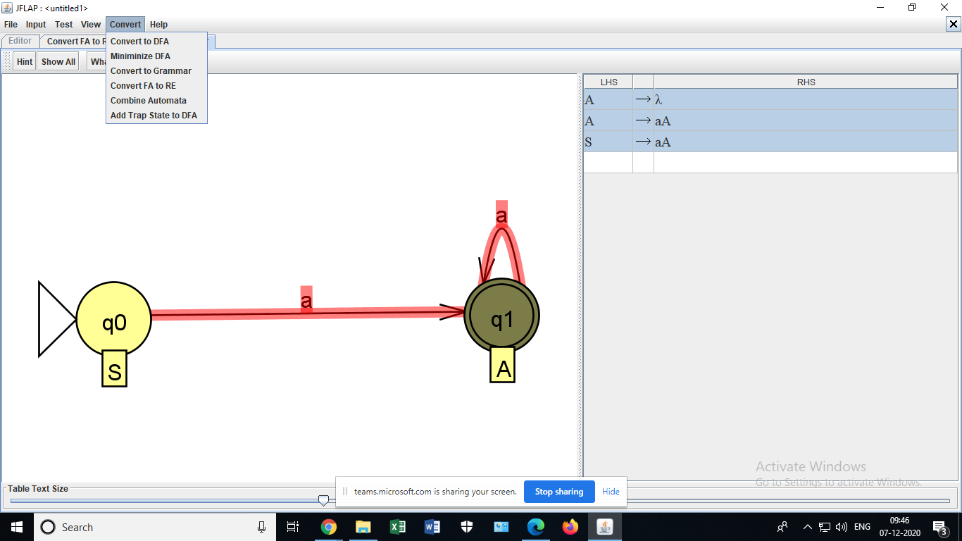

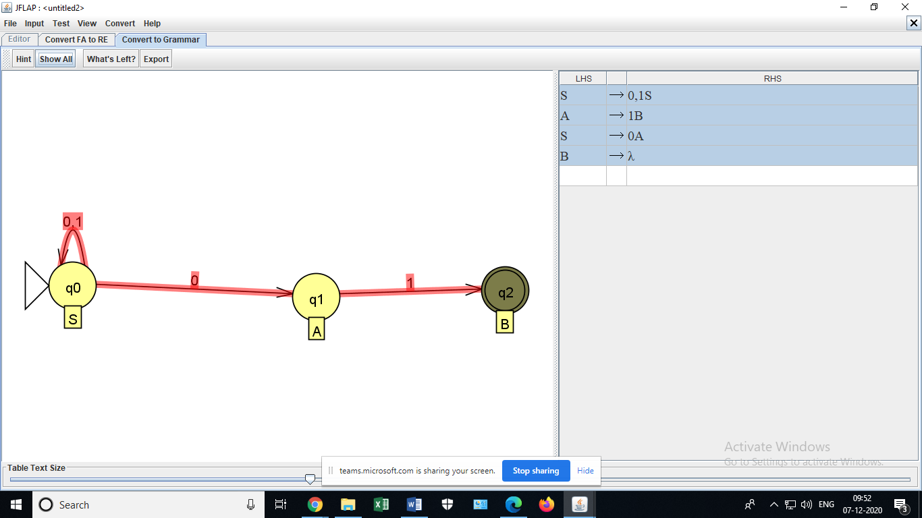

- Tinkercad simulation tool is used to verify the truth table of IC pin diagrams and screenshots is shown below:

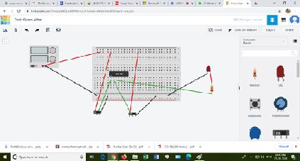
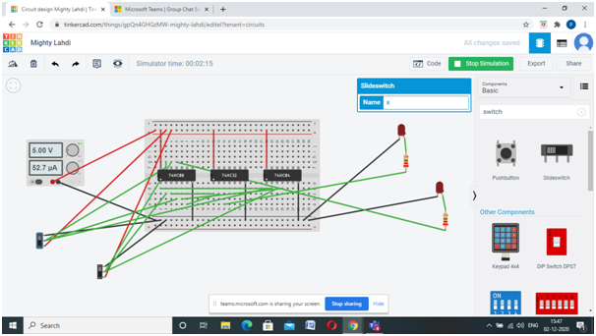

- Flipped classrooms:
It is a blended learning method, applied to increase student engagement and learning. Few photos are captured while conducting flipflop classroom is as shown below:

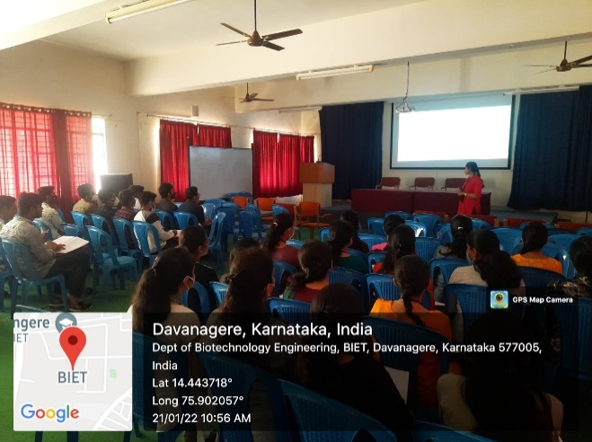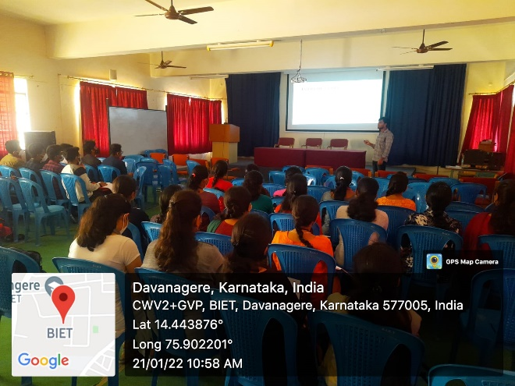

- Google Classroom

Google Classroom is a blended learning plaform that aims to simplify, creating, distributing and grading assignments. Faculty have used Google Classroom platform to share academic materials like notes,assignments,videos,presentations etc. to the students.

