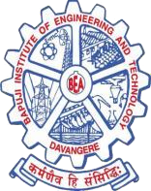

Bapuji Educational Association (Regd.)
Bapuji Institute of Engineering and Technology, Davangere-04
(Affiliated to VTU Belagavi, Approved by AICTE, New Delhi)
Accredited by the NAAC with A Grade

INFO VOICE
Department of Information Science and Engineering

Volume-7 August 2023 - July 2024

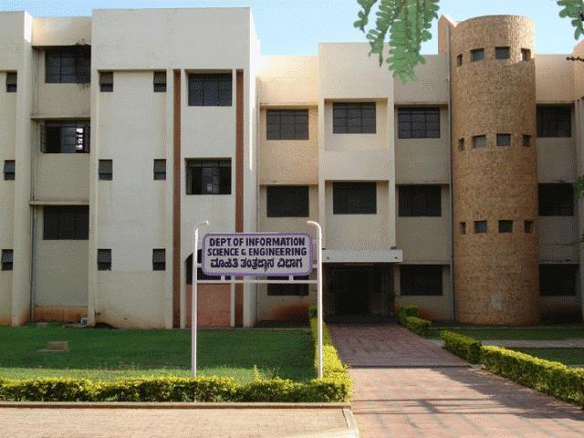

“The aim of education is the knowledge, not of facts, but of values.”
- William S. Burroughs
-

Vision of the Institute
“To be center of excellence recognized nationally and internationally, in distinctive areas of
engineering education and research, based on a culture of innovation and invention.”

Mission of the Institute
“BIET contributes to the growth and development of its students by imparting a board based engineering education and empowering them to be successful in their chosen field by inculcating in them positive approach, leadership qualities and ethical values.”

Vision of the Department
“To be the center of excellence by adopting technological innovation in academics and research
to develop competent man power for emerging needs of society and industries.”

Mission of the Department
M1: To provide quality education to meet the challenges of technological changes to succeed in their professional career and higher education.
M2: To inculcate the culture of research, innovation and entrepreneur skills among the students.
M3: To groom our students with the quality of team spirit, leadership skills and ethical values, to share and apply their knowledge for the benefit of the society.

Program Educational Objectives (PEOs):

PEO1- The graduates of program will have excellence through principles and practices of Information Technology combined with Fundamentals of Engineering.
PEO2 - The graduates of program will be prepared in diverse areas of Information Science for their
successful careers, entrepreneurship and higher studies.
PEO3 - The graduates of program will work effectively as an individual and in a team, exhibiting
leadership qualities, communication skills to meet the goals of the organization.
PEO4 - The graduates of program will grove their profession with ethics, Management principles to carry
societal responsibilities.

Program Specific Outcomes (PSOs):
PSO1: Problem Solving Skills - Ability to apply standard principles and practices of Information Technology to propose feasible ideas and solutions to computational tasks using appropriate tools and Techniques.
PSO2: Knowledge of Information Technology – Analyze, Design, Develop and Test the computer based software in the areas related to Algorithms, Networks, Cloud Computing, Web, Data Science and IoT.
PSO3: Profession and Research Ability – Inculcate the knowledge to excel in IT profession, Entrepreneurship and research with Ethical standards.

The objectives of the newsletter:
- To Exhibit the achievements of the Students and Faculty members from the Department of Information Science and Engineering in Curricular, Co-curricular and Extra-curricular Activities.
- To publish the recent trends in the area of Information Science & Engineering and related areas.

About the Department:
The department was established in the year 2000 with an intake of 60 students and it is increased to 120 in the year 2007, 150 in the year 2021,180 in the year 2022 and 300 in the year 2024. The department is equipped with all necessary infrastructure and laboratory facilities. Keeping in view of the vision of the department, the department of Information Science is working to achieve excellence in various aspects such as: students’ performance, effective teacher-student relationship, imparting quality education to students, motivating faculty and students towards research and imbibing best human qualities in students.
The department has a strong and active Forum INSYNC helping in all-round development of the students through various Technical Workshops on Recent Technologies like Big Data, Cloud Computing, Python, Android, IoT etc. Extensive placement trainings are conducted to improve employability of the students. The faculty of the department is actively involved in research activities in various technical domains.
The department has established Industry 4.0 Center of Excellence in collaboration with Rovelabs, Bengaluru to adapt itself to the rapid advancements in various specialized fields.

NEWS LETTER COMMITTEE
Patrons

Dr. Shamanur Shivashankarappa
MLA, Hon. Secretary, BEA

Sri. S. S. Mallikarjun
Joint Secretary, BEA

Advisory Board

Prof. Y. Vrushabhendrappa
Director, BIET

Dr. H B Aravinda
Principal, BIET

Dr. Poornima B.
Professor and Head

Editor
Prof. Rekha B.H
Assistant Professor

Associate Editor Prof. Puneeth S P Assistant Professor

Student Editors Mr. Prashanth R S Mr. Prajwal C M Ms. Kruthika N
Ms. Sahana Achar

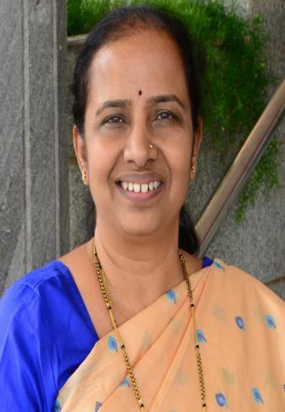
Message from HOD’s Desk:
I am happy to note that the Department of Information Science and Engineering is releasing its Newsletter for Academic Year 2023-24 (Volume 7) and enumerating the various activities of our faculty and students. Working towards the overall development of the students, the department is committed to bring the best of the students through this newsletter. Education is more important in our life than learning or being literate. The Newsletter is a good way to learn about developments and activities of the department and to let others know. I congratulate all the people who have been associated with this publication.

Dr. Poornima B. Prof. & Head, Dept. of IS&E

Activities Conducted in the Department

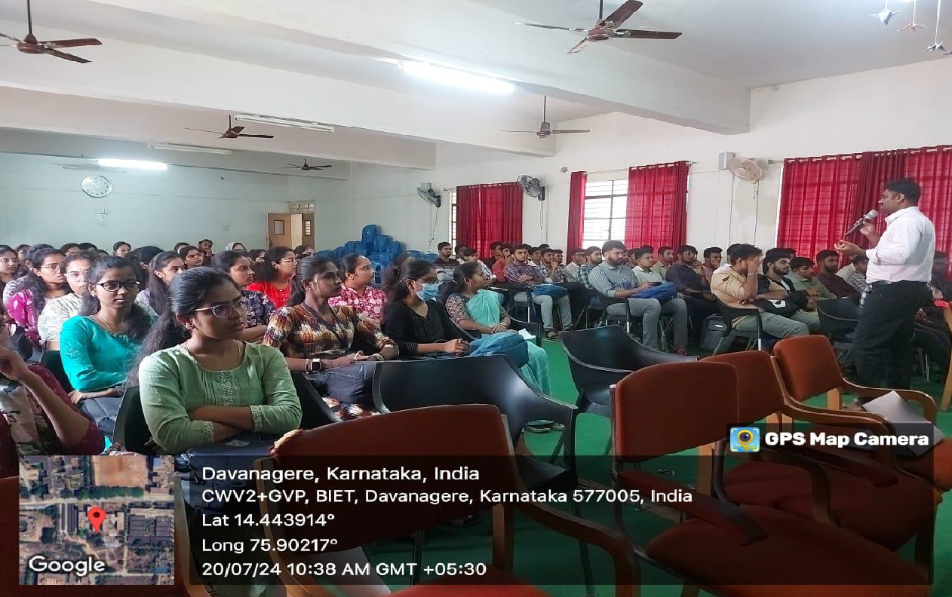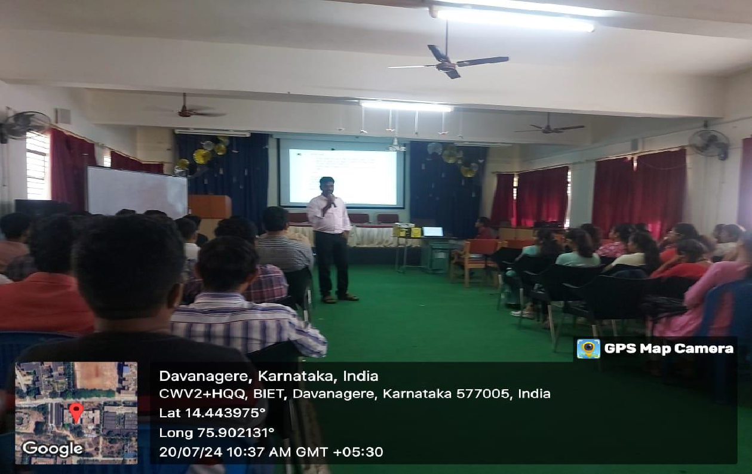
Two Days Workshop on Code and Test: Building with Selenium was conducted on 20th and 21st July 2024 for sixth semester students.
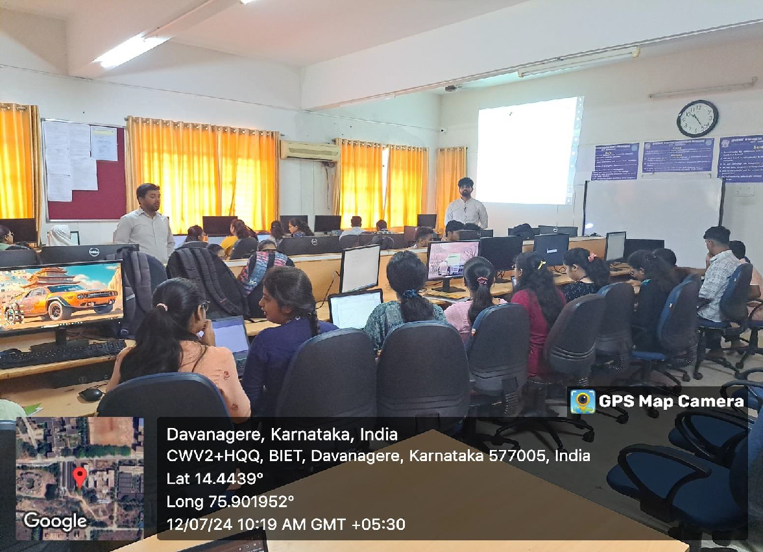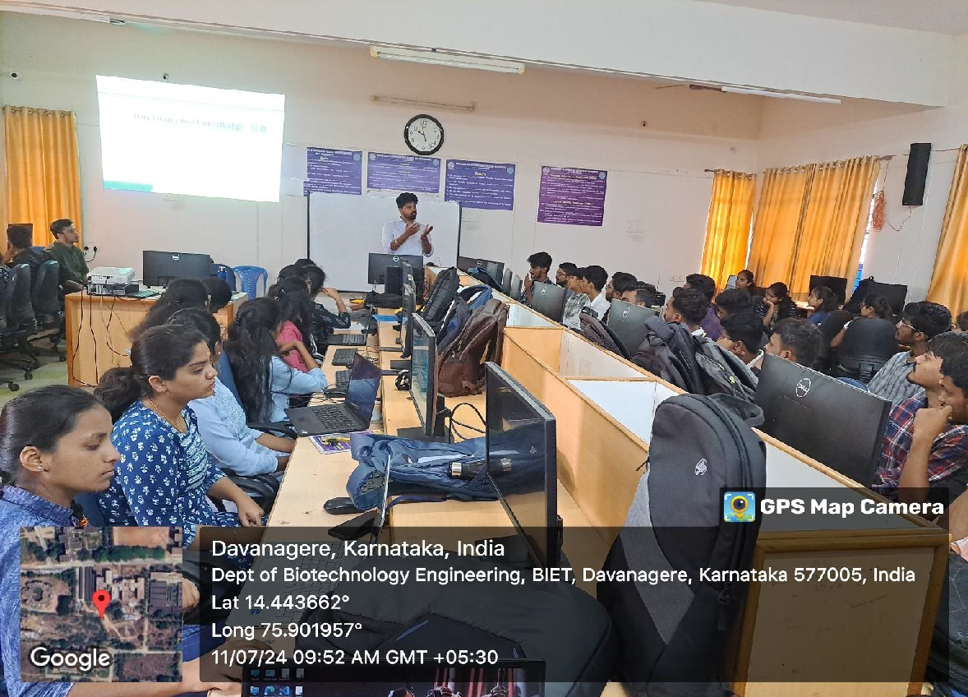
Three Days Workshop on “Practical exposure towards Data Science and Data Visualization using MatPlot Libs was conducted from 11th to 13th July 2024 for sixth semester students.

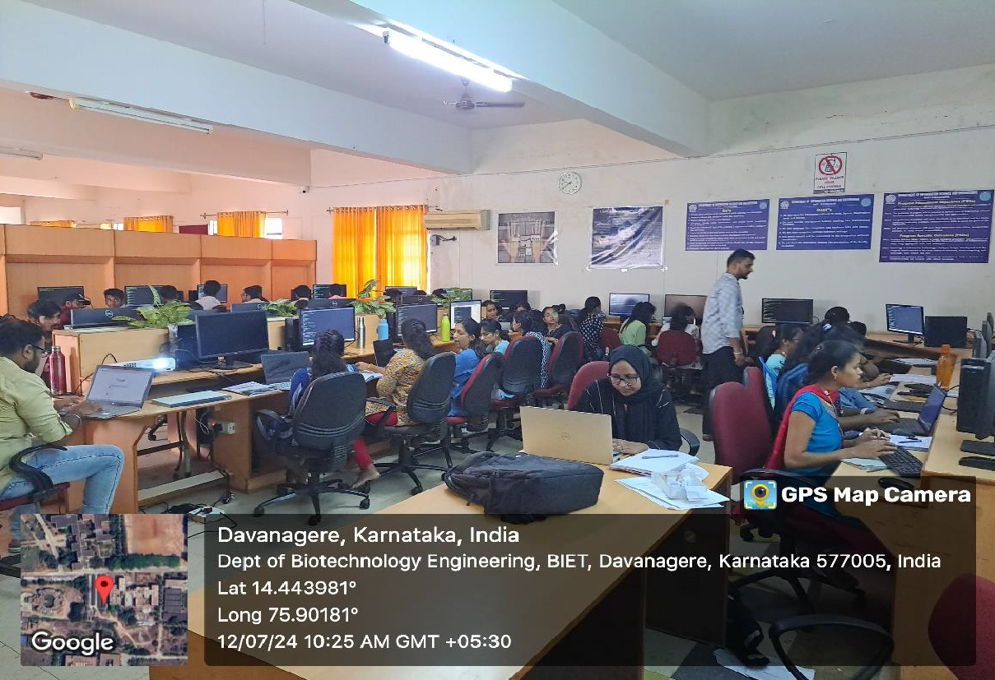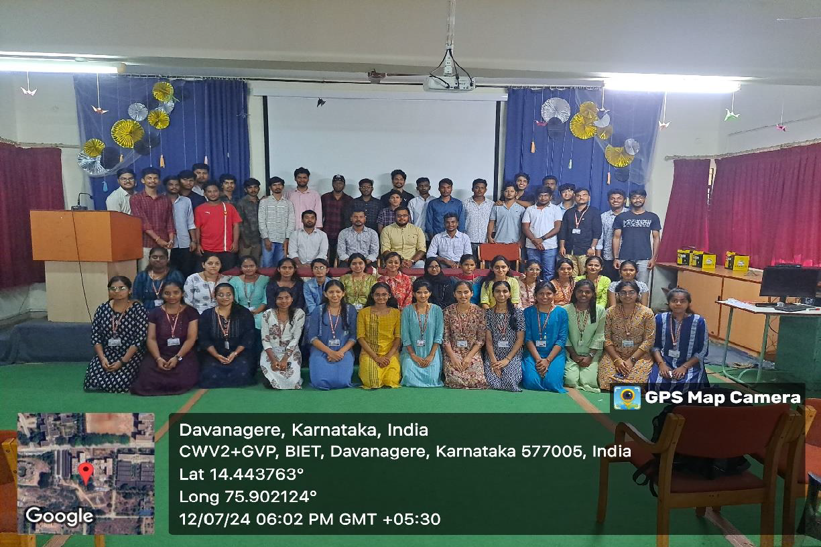
Three Days Workshop on DBMS Applications Development using Mongo DB was conducted from 11th to 13th July 2024 for sixth semester students.

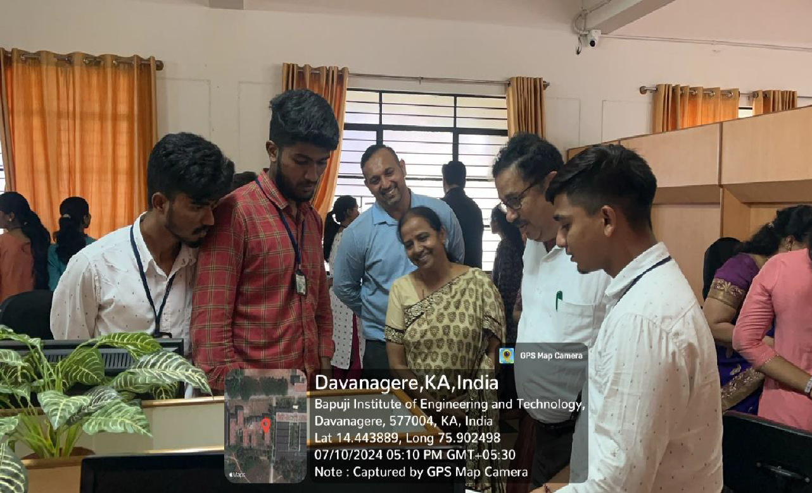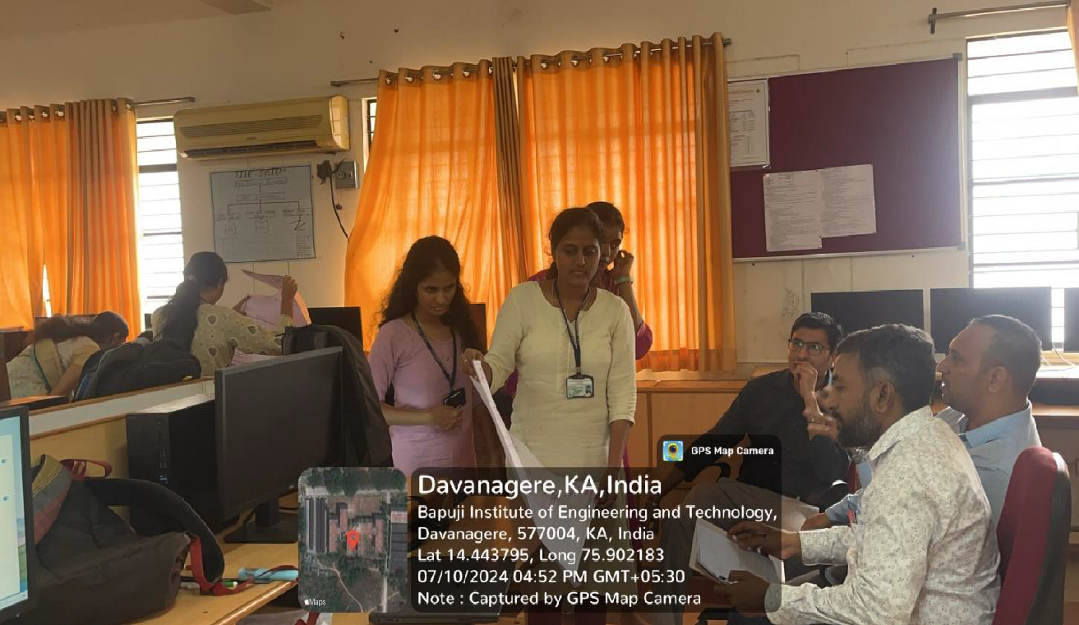
One Day Mini Project Development and Exhibition Program PROJECTATHON was conducted on 10th July 2024 for sixth semester students.

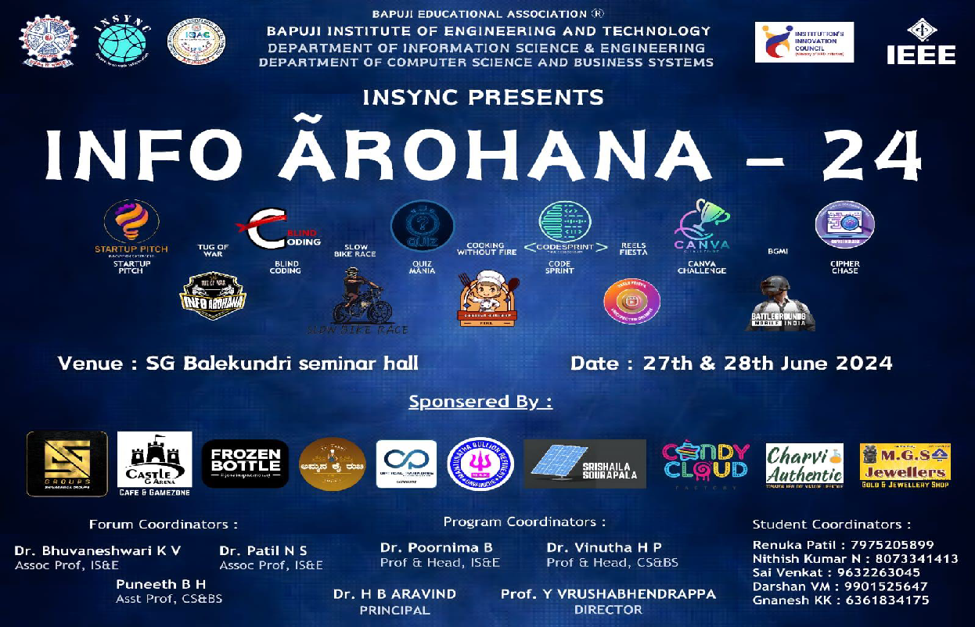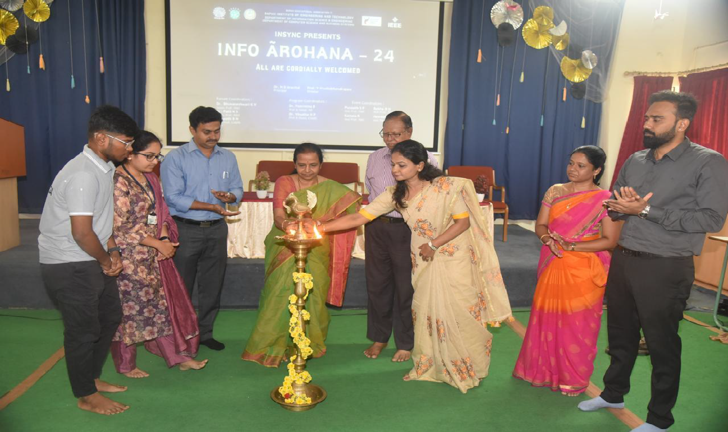
Branch Fest “Info-Arohana 24” was organized by IS&E department in associated with ISTE, IEI, EEE, IIC and IQAC was conducted during the period of 27th and 28th June 2024.

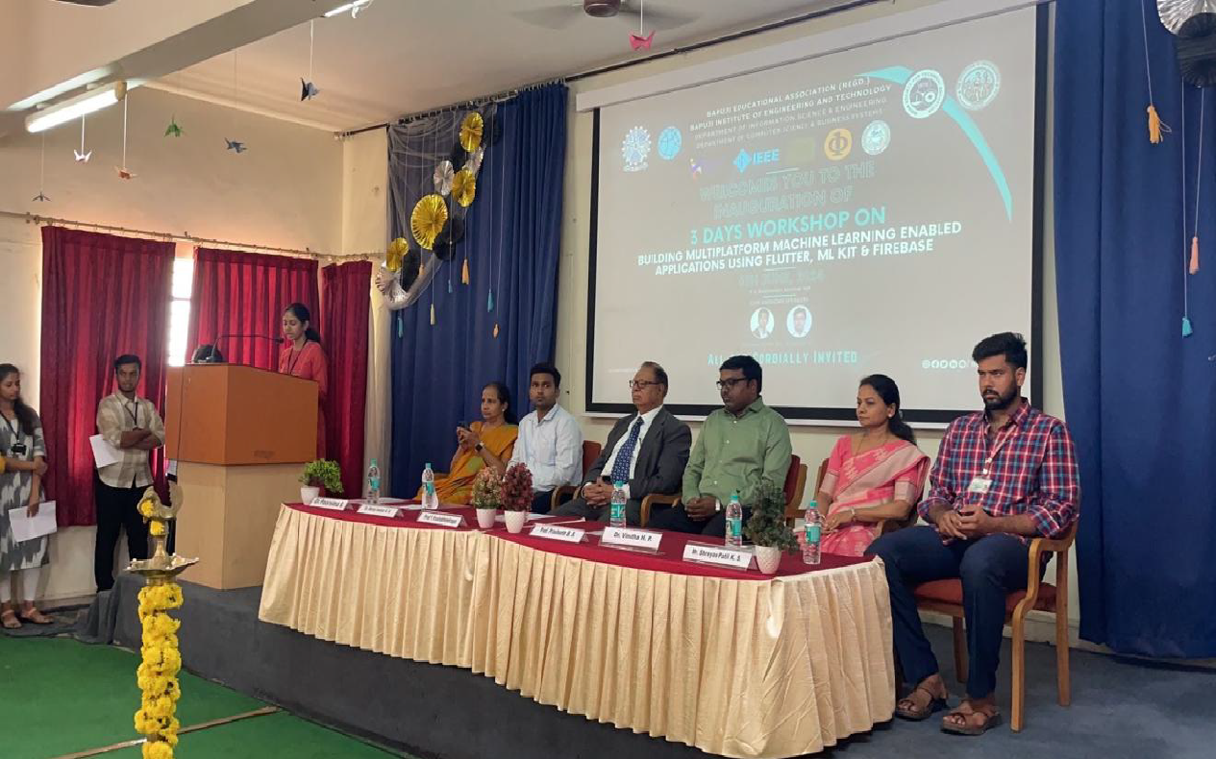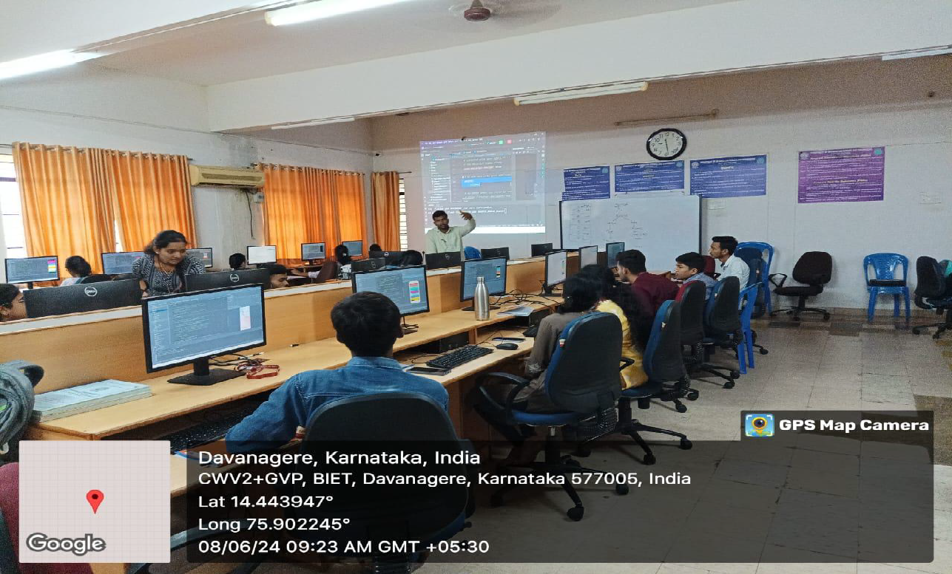
Three Days Workshop on Building Multiplatform Machine Learning Applications using Flutter, ML Kit and Firebase was conducted for students from 7th to 9th June 2024 in association with IEEE.

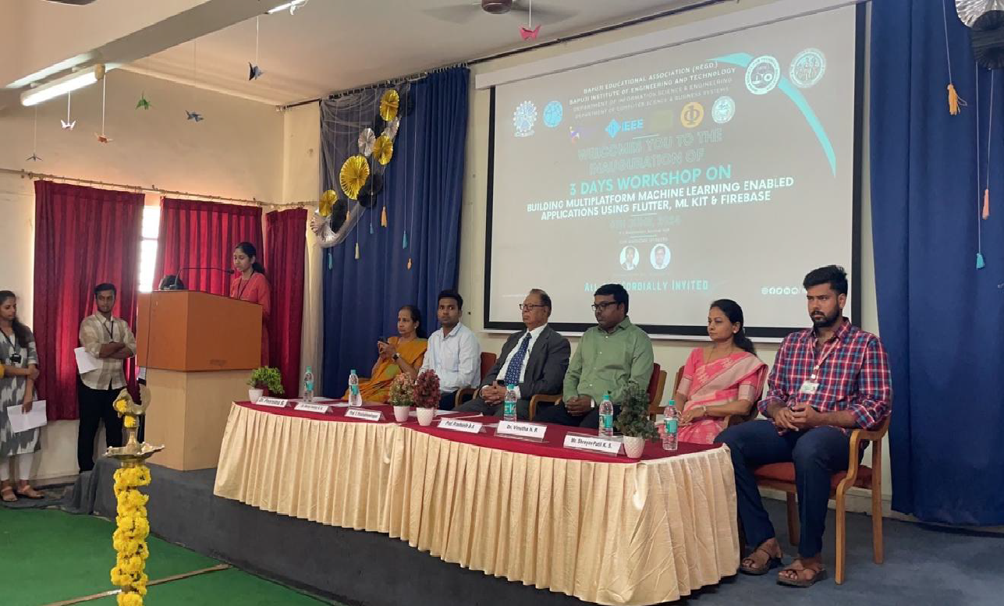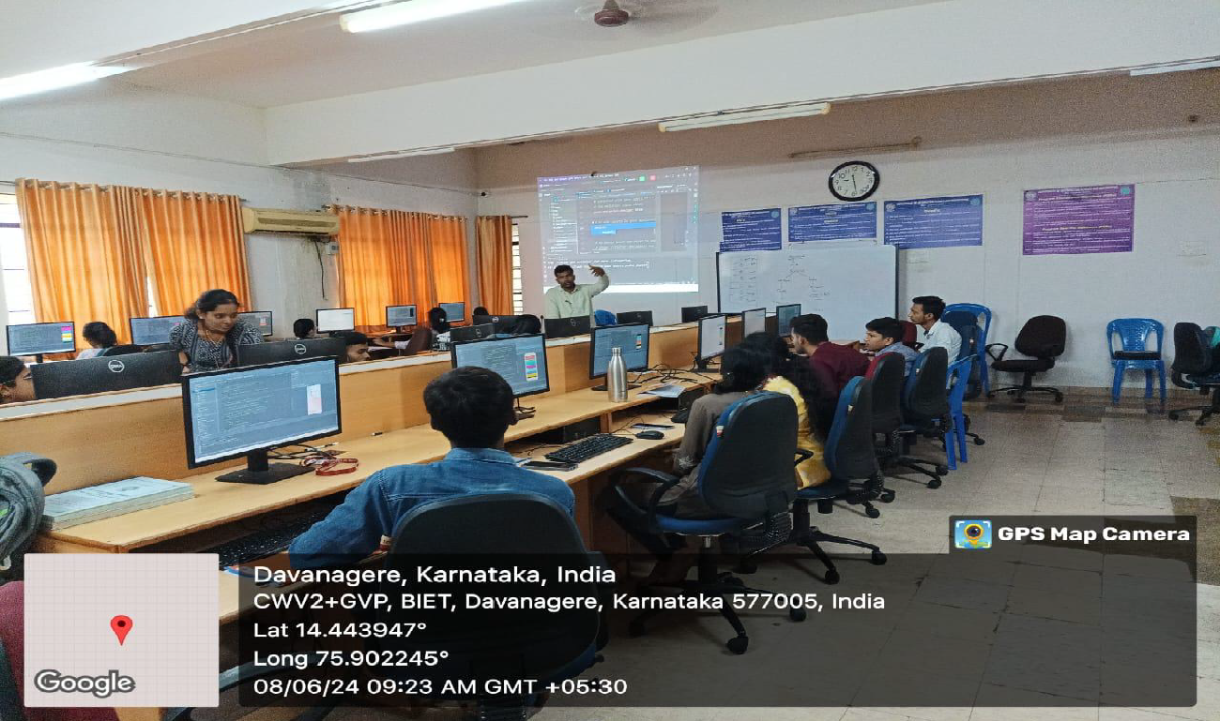
“HackTechFusion2.0” A technical coding competition held on 6th June 2024 in association with NAIN, IEEE, ISTE and IEI.

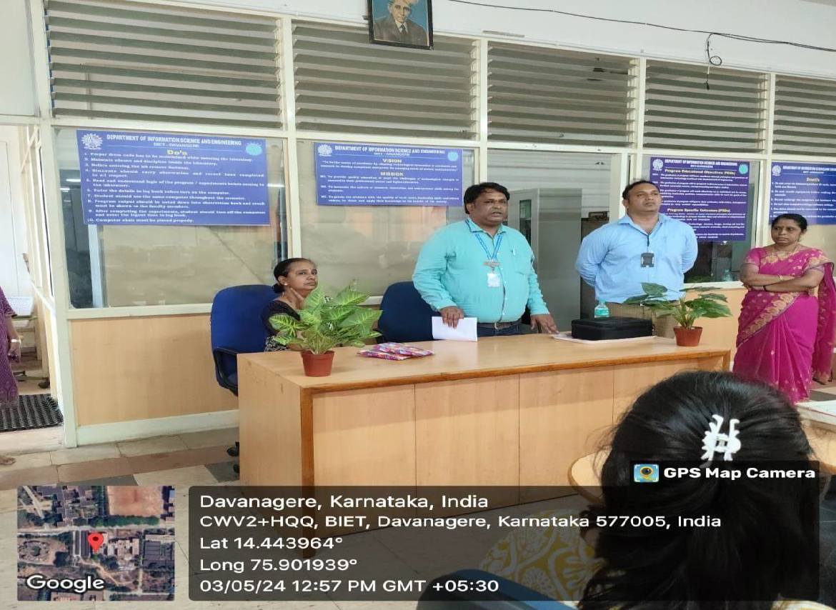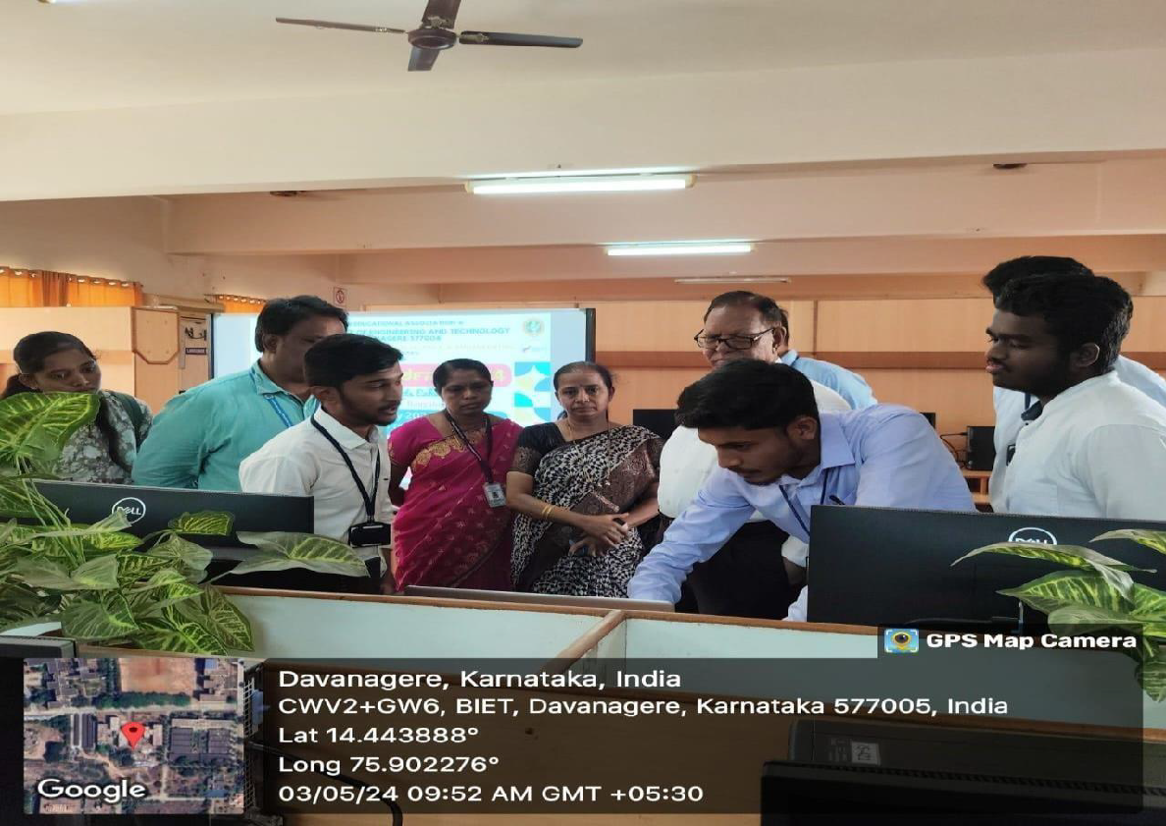
Project ಪ್ರ ದರ್ಶನ -2K24 Final Year Project Exhibition in Association with IEEE was
conducted on 3rd May 2024.

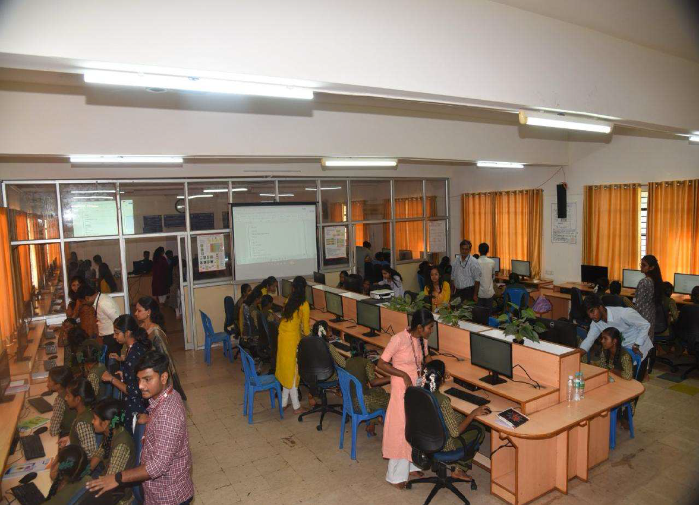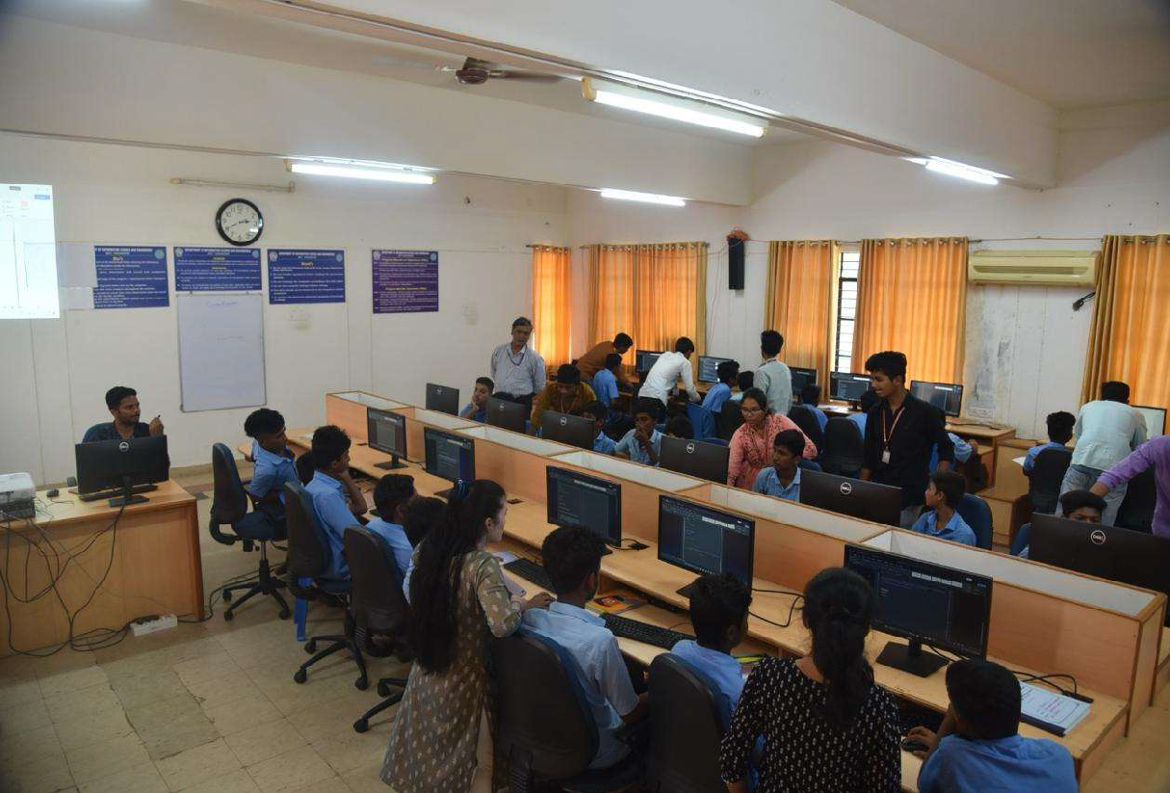
Computer Awareness Program in association with SS Care Trust was conducted on 22nd Feb 2024 for Government School Students.

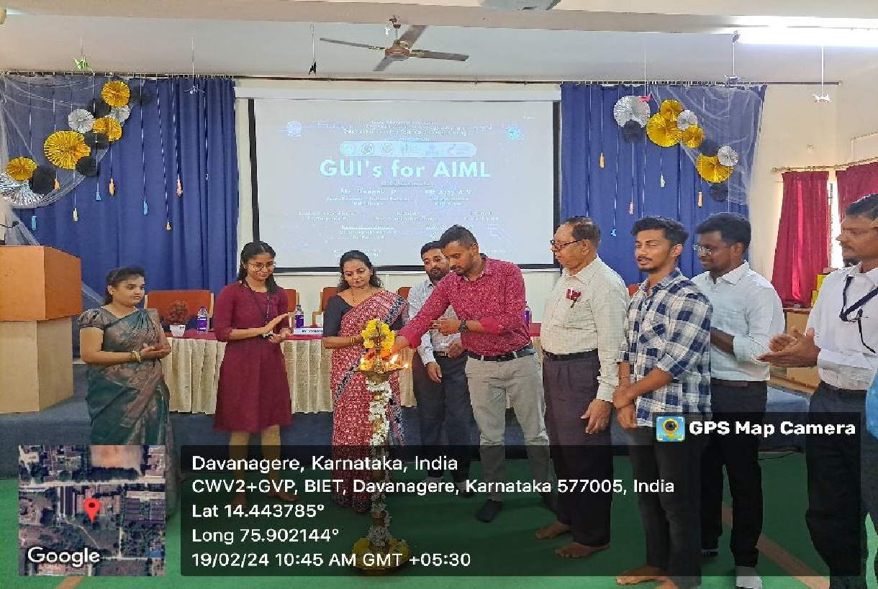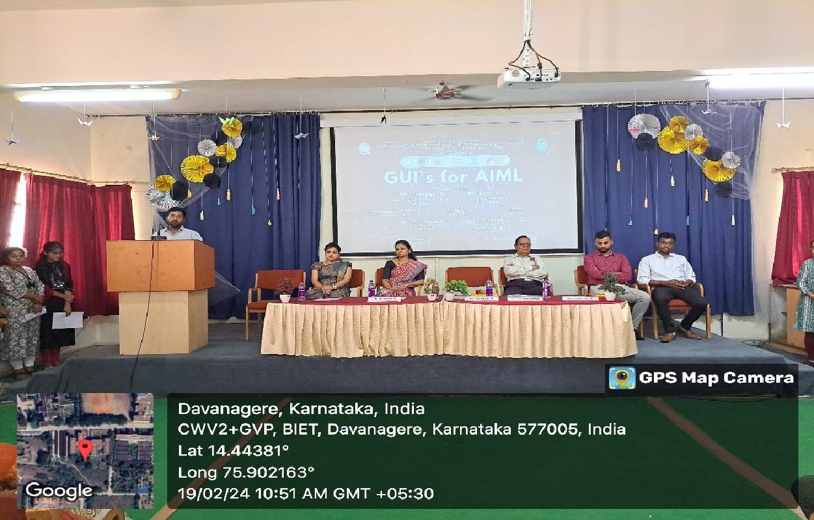
Five Days Workshop on GUI’s for AIML was conducted for 5th semester Students during the period of 19th and 23rd Feb 2024 in association with ISTE and IEEE.

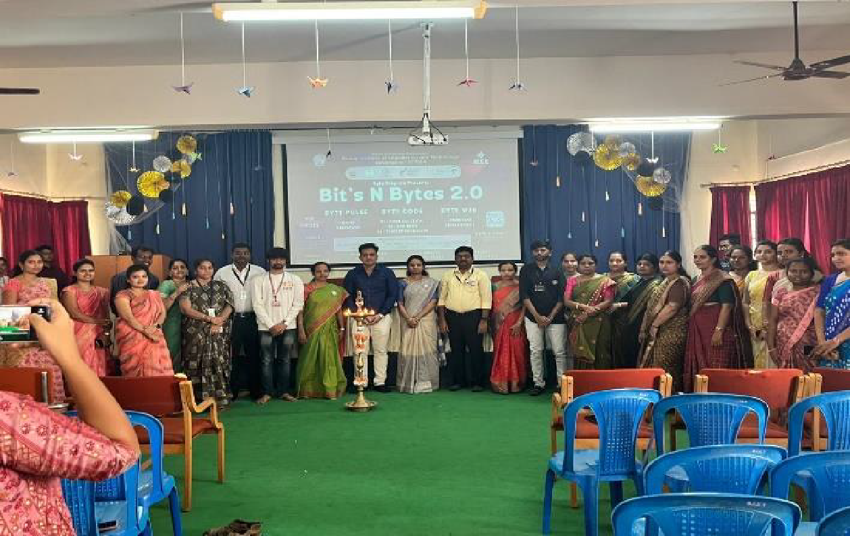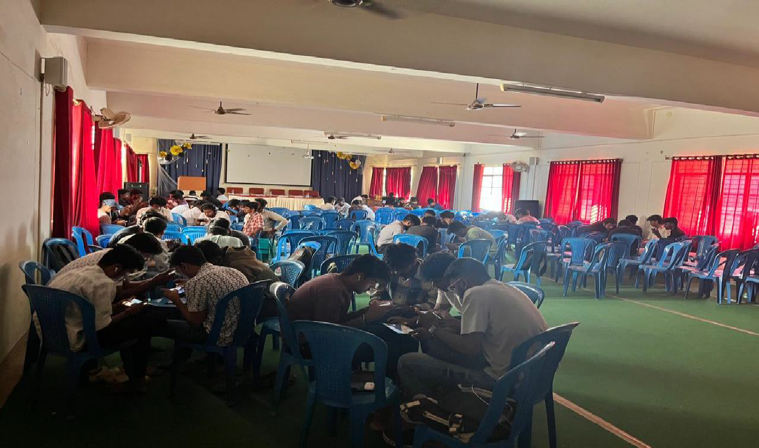
Coding Competition Bit’s N Bytes 2.0 was conducted for students by IS&E Dept. on 12th Feb 2024 in association with ISTE.

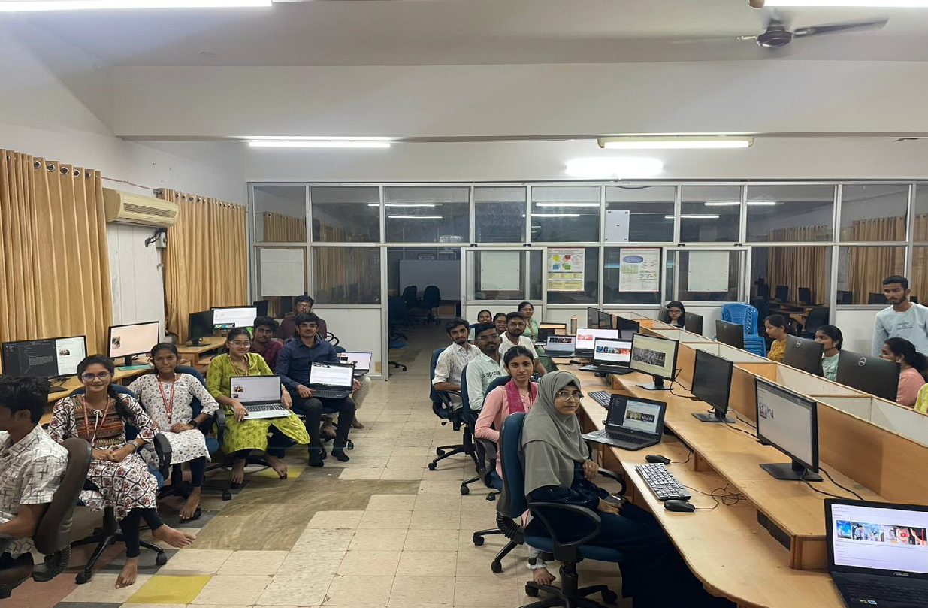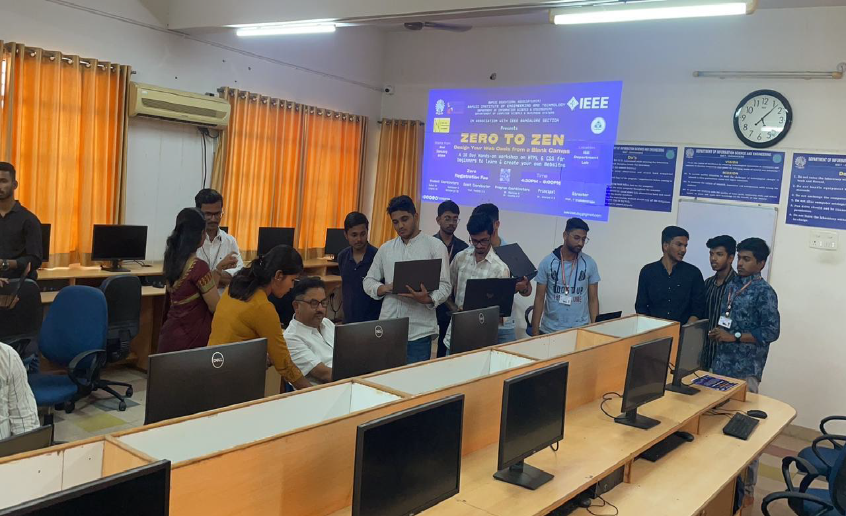

Zero to Zen 10 Days Hands on Web Development Workshop was conducted from Jan 3rd to 18^{th.}

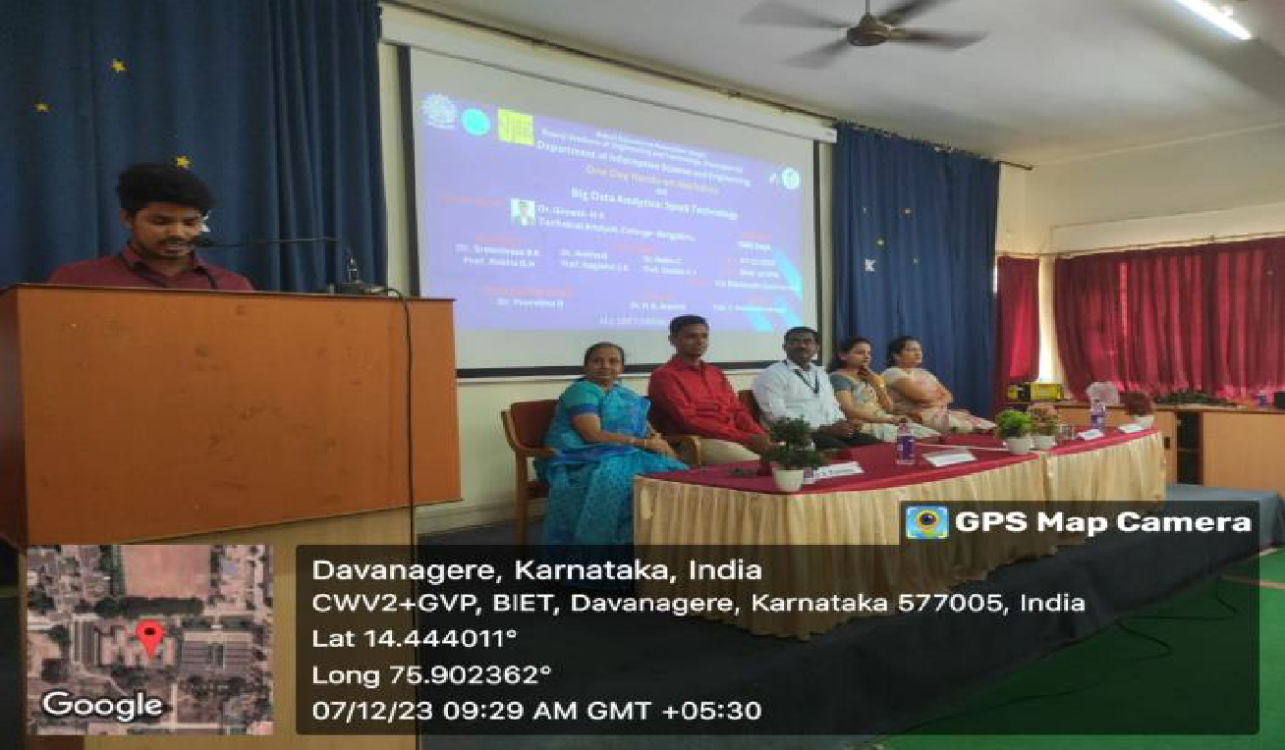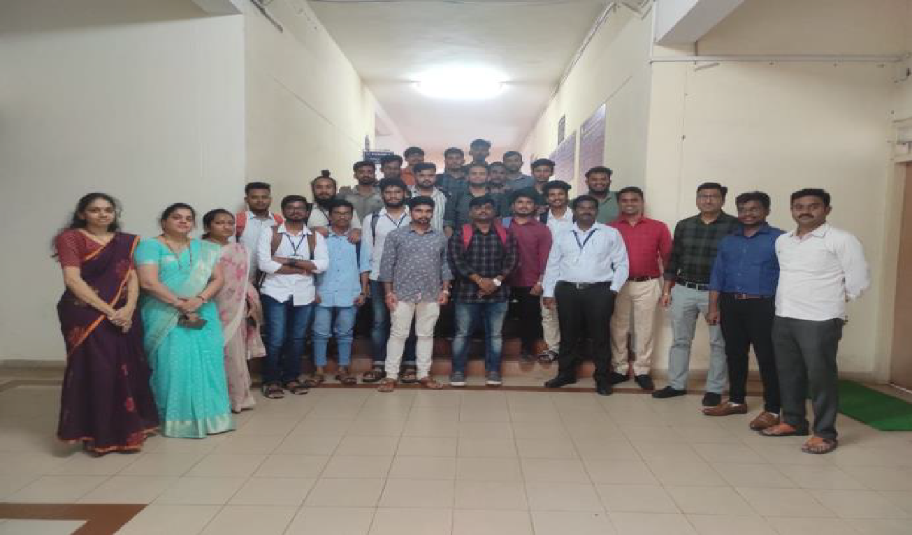
One Day Hands-on Workshop Big Data Analytics: Spark Technology was conducted for 7th semester students on 7th Dec 2023 in association with IQAC.

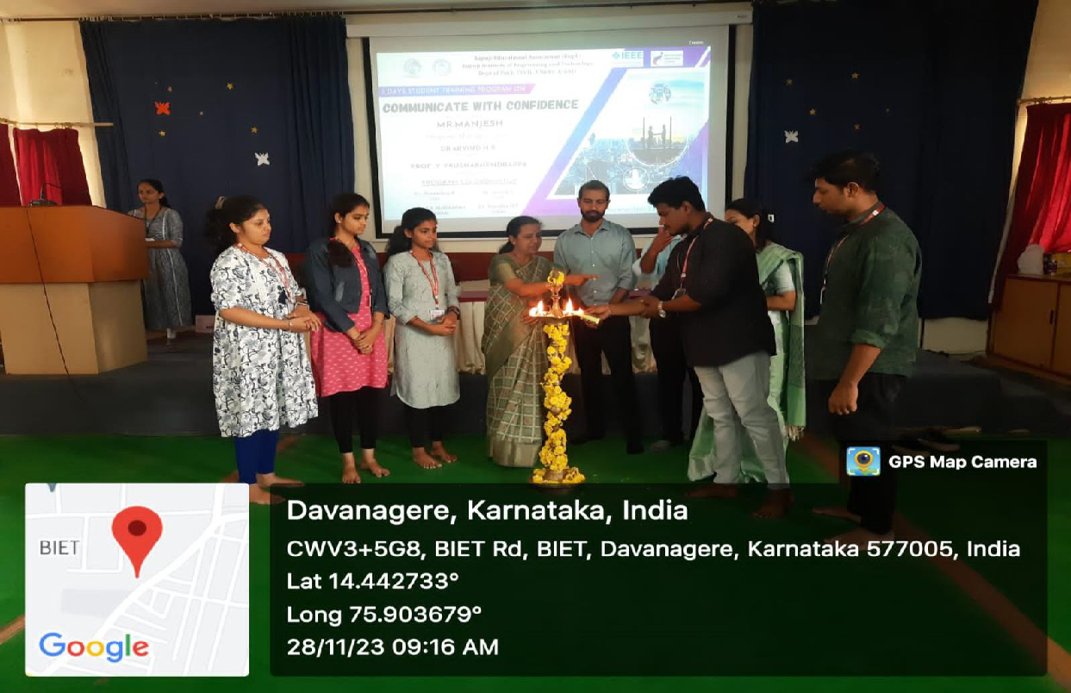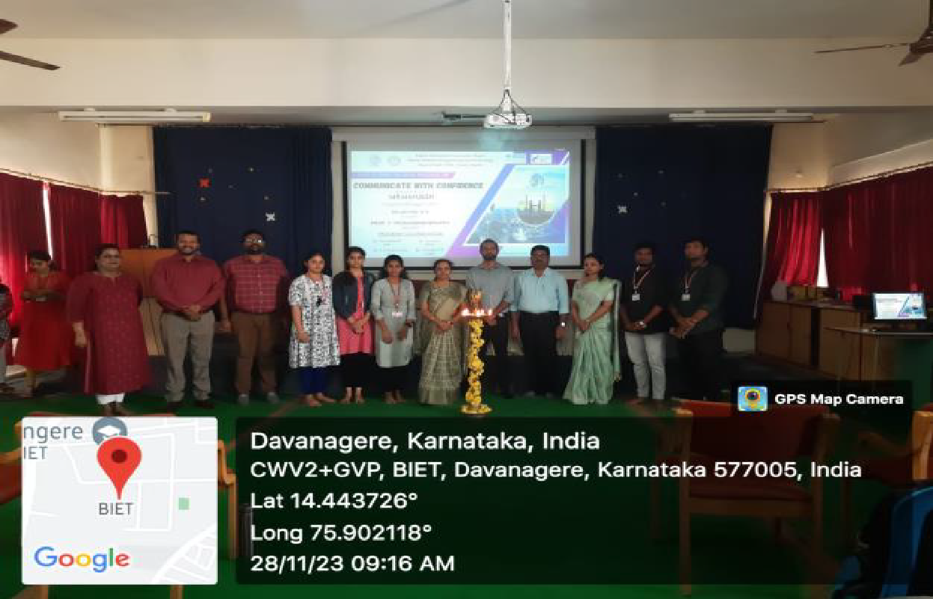
Five Days Student Training Program on Communicate with Confidence was conducted for Students on 28th Nov 2023.
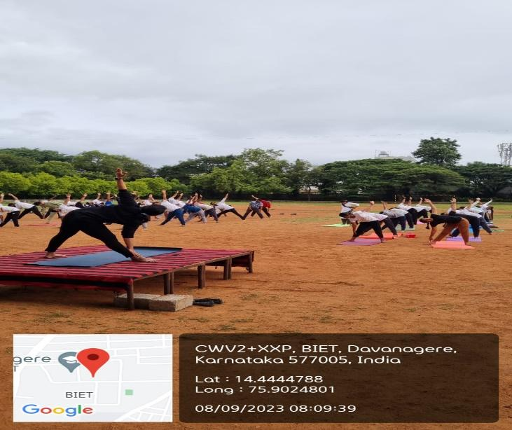

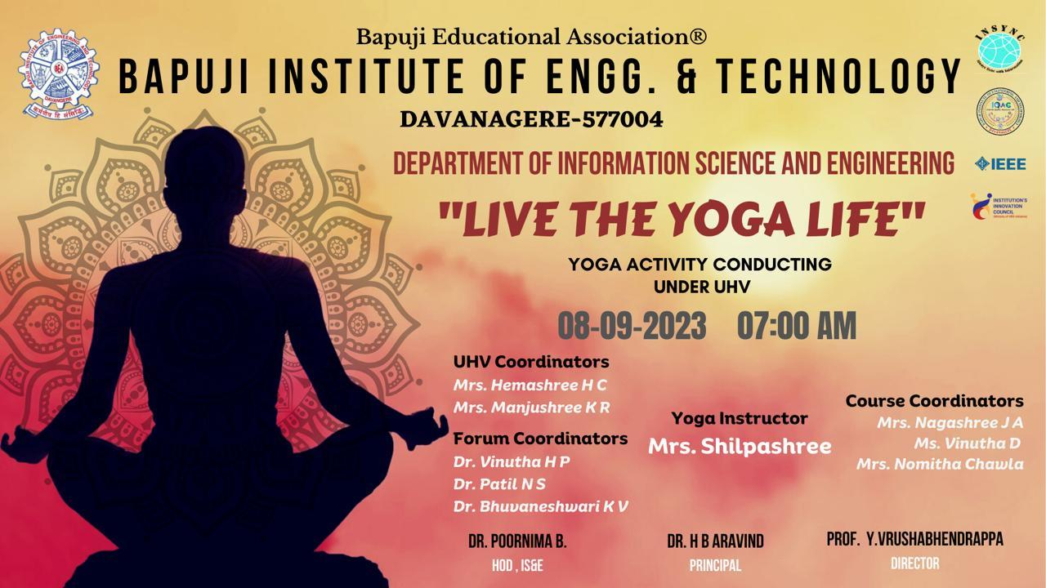
Live the Yoga Life was conducted on 8th Sep 2023 for students.

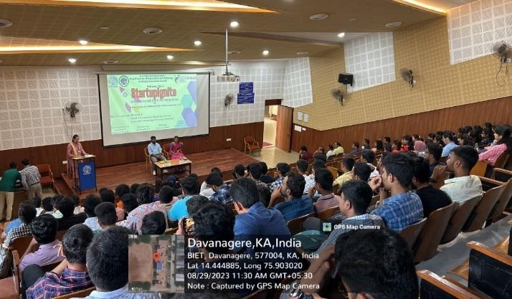
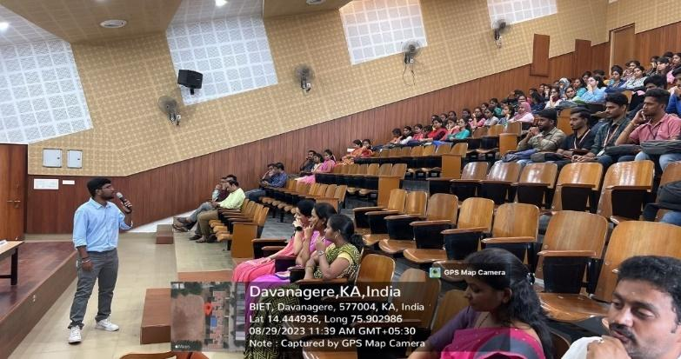

Startupignite was conducted for Students on 29th Aug 2023 in association with ISTE and IEEE.

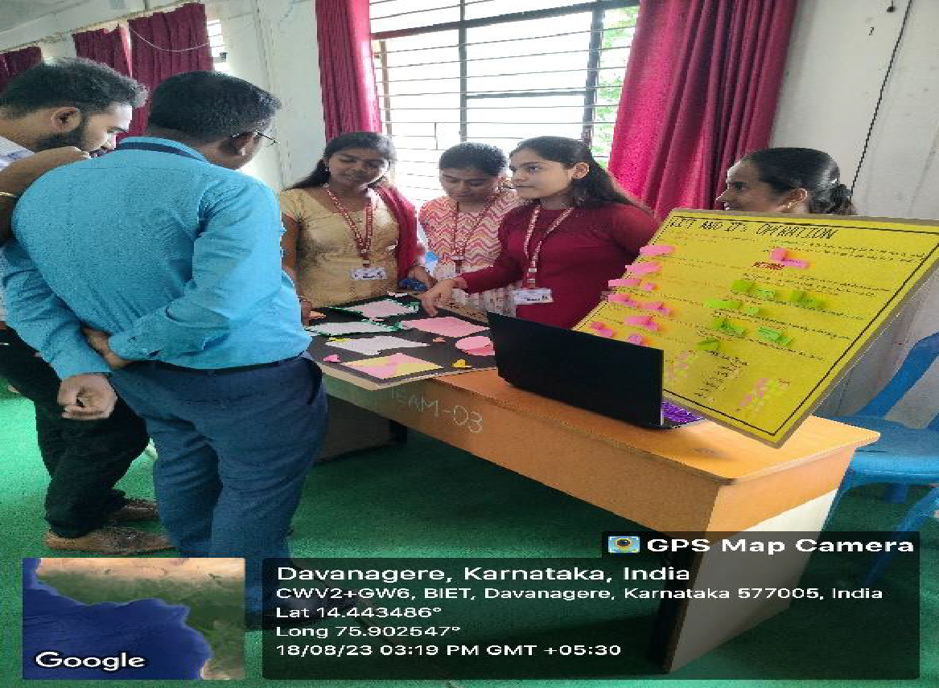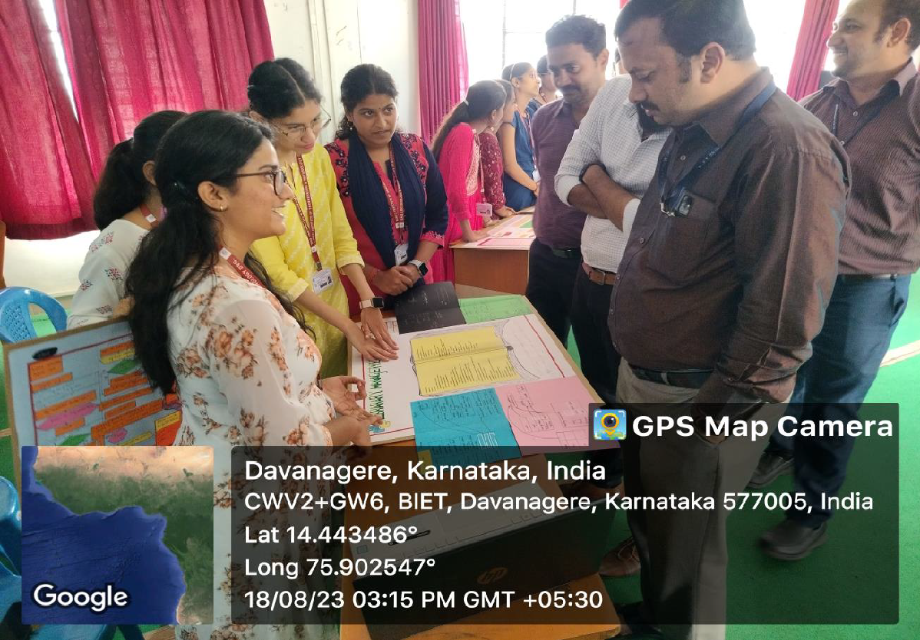
Technical Presentation Competition on Python Envoi was conducted for 1st Year E section Students on 18th Aug 2023 in association with ISTE and IEEE.

Faculty Publication for the year Aug 2023-July 2024
- Dr Vinutha H P,” Survey on Bovine Mastitis: A Common Dairy Disease “in YMER, https://Ymerdigital.Com/Uploads/YMER%20230142.Pdf, Impact Factor:1.8.
- Dr. Ashoka K, “A Comprehensive Survey Exploring the Application of Machine Learning Algorithms in The Detection of Land Degradation”, in Journal of Degraded and Mining Lands Management. (Scopus Q3-Journal), DOI: 10.15243/Jdmlm, Impact Factor:0.23.
- Dr. Anitha G, “Analysis and Classification of COPD Using Deep Learning”, in International Advanced Research Journal in Science, Engineering and Technology, DOI: 10.17148/IARJSET.2024.114108, Impact Factor:8.066.
- Dr. Rekha C,” IoT Based Women Safety Jacket Using Arduino”, in International Journal of Innovative Research in Computer and Communication Engineering, DOI: 10.15680/IJIRCCE.2024.1205265, Impact Factor:8.379.
- Dr.Bhuvaneshwari K V,” Sign Language Recognition Using Machine Learning”, in International Journal of Innovative Science and Research Technology (IJISRT), https://Doi.Org/10.38124/Ijisrt/IJISRT24MAY273, Impact Factor:8.223.

- Dr Patil N S,” A Data-Centric Internet of Things Framework Based on Azure Cloud “,in Science, Technology and Development, DOI:16.10089/STD.

- D. Shivamurthy,” Traffic Violation Control and Management”, in International Journal of Innovative Research in Computer and Communication Engineering (IJIRCCE), Impact factor:8.379, DOI:10.15680/IJIRCCE.2024.1205251.

- Prof. Rekha B H,” Life Detection for Rescue Operations Under Collapsed Buildings”, International Journal of Innovative Research in Science, Engineering and Technology (IJIRSET), Impact factor: 8.423 DOI:10.15680/IJIRSET.2024.1305129.

- Prof.Puneeth S P,” A Survey on Deep Learning Based Automatic Detection of Bike Riders with No Helmet”, in International Journal of Progressive Research In Engineering Management and Science (IJPREMS), Impact Factor: 5.725, Vol. 04, Issue 02, February 2024, pp: 566-568.

- Prof. Hemashree H C,” Classification of Oral Lesions using Deep Learning: A Retrospective Study”, in International Journal of Science and Research (IJSR), Impact factor: 7.942, DOI: https://dx.doi.org/10.21275/SR24402113631.

- Prof. Santhosh T,” Automated Health Monitoring and Food Supply System for Poultry Farming”, in International Journal of Progressive Research In Engineering Management And Science (IJPREMS), DOI: https://www.doi.org/10.58257/IJPREMS34212.

- Prof.Sushma C,” Chatbot Using Open AI”, in International Journal of Innovative Research in Science, Engineering and Technology, Impact factor:8.423, DOI:10.15680/IJIRSET.2024.1305036.

- Prof.Kamala R,” RFID Based Electronic Voting Machine”, in International Journal of Innovative Research in Computer and Communication Engineering (IJIRCCE), Impact factor:8.379, DOI:10.15680/IJIRCCE.2024.1204316.

- Prof.Roopa D E,” Smartphone recommendation System “,in International Journal of Innovative Research in computer and communication Engineering, Impact factor:8.379, DOI:10.15680/IJIRCCE.2024.1205160.

- Prof.Madhuri Martis,” Charging Station for E-Vehicle using solar with IoT”, in International Journal of Innovative Research in Computer and Communication Engineering, Impact factor:8.379, DOI:10.15680/IJIRCCE.2024.1205146

- Prof. Nagashri J A,” Patellofemoral Arthritis Prediction Using Machine Learning “, in International Journal of Innovative Research in Computer and Communication Engineering, Impact factor:8.379, DOI: 10.15680/IJIRCCE.2024.1205020

- Prof.Vinutha D ,“Blink Sync Wheelchair: Navigating Independence Through Eyeball Movement Control”, in International Journal of Innovative Research in Science, Engineering and Technology, Impact factor:8.423, DOI:10.15680/IJIRSET.2024.1305394.

Faculty Participation in FDP/Workshops for the year [Aug-2023 to July 2024]

- Dr.Rekha C, Participated in Three Day Workshop on “Technical Writing using LaTeX” from 7th to 9th May 2024, organized by SJC Institute of Technology.
- Dr. Anitha G. attended Five-day FDP on “Data Science Applications in Real-World using Python” from 18th to 22nd Mar 2024, organized by Indira College of Engineering and Management, Pune.
- Dr. Bhuvaneshwari K. V, Participated in Five-day FDP on “Full Stack Development”, from 22nd to 26th April 2024, organized by BIT, Bengaluru.
- Rekha B.H, attended Three-day workshop on “Mentoring Project for Impact” from 10th to 12th Jun 2024 ,organized by ICT Academy at Kristu Jayanti College, Bangalore
- Puneeth S. P. attended Five-day FDP on “Data Science Applications in Real-World using Python” from 18th to 22nd Mar 2024, organized by Indira College of Engineering and Management, Pune.
- Hemashree H. C, Participated in Five-day FDP on “Full Stack Development”, from 22nd to 26th April 2024, organized by BIT, Bengaluru.
- Santhosh T, Participated in Five-day FDP on “Full Stack Development”, from 22nd to 26th April 2024, organized by BIT, Bengaluru.
- Manjushree K. R., Participated in Five-day FDP on “Full Stack Development”, from 22nd to 26th April 2024, organized by BIT, Bengaluru.
- Roopa D E, Participated in Three-day FDP on “Mongo DB”, from 22nd to 24th April 2024, organized by BIT, Bengaluru.
- Nagashri J A, Participated in Five-day FDP on “Full Stack Development”, from 29th to 3rd May 2024, organized by BIT, Bengaluru.
- Chaitra K J, Participated in Five-day FDP on “Business Analytics”, from 5th to 9th Feb 2024, organized by AISSMS College of Engineering, Pune.
- Madhuri Martis, Participated in Five-day FDP on “Mongo DB”, from 22nd to 24th April 2024, organized by BIT, Bengaluru.
- Chaitra K G, Participated in Five-day FDP on “Mongo DB”, from 22nd to 24th April 2024, organized by BIT, Bengaluru.

Students’ Participation in Co-curricular and Extra-curricular Activities
for the Year 2023-24

SL.  No | Students Name  &  USN | Name of the Workshop/  Seminar/  Lecture/  Conference/  Competition/  Course/Fest | Organized By | Date | Participated/  Presented/  Published/  Completed | Prizes Won (if any)
1 | Lingaraju M  4BD20IS037  Mohith H Giriyapur,  4BD20IS043  Nagabhushan B V,  4BD20IS044  Nithin K K  4BD20IS053 | Nirmana 4.0 | Inhouse Project Exhibition,BIET,Dvg | 25-05-2024 | Charging Station for e-vehicle using solar with IoT | Best Project
2 | Varun B P  4BD21IS153 | Technzone-2024-A State Level Technical Symposium | JNNCE, Shivamogga | 02-05-2024 &  03-05-2024 | Start Buiz | 2nd Place
3 | Kavana M M  4BD21IS403 | 1st International Conference on Multi-Disciplinary research Trends in Engineering & Technology | Smt.Kamala & Sri Venkappa M Agadi College of Engineering & Technology,Lakeshmeshwar | 12-03-2024 &  13-03-2024 | Ensemble Machine Learning techniques for the classification of brain tumor | -
4 | Keerthana K  4BD20IS034 | 1st International Conference on Multi-Disciplinary research Trends in Engineering & Technology | Smt.Kamala & Sri Venkappa M Agadi College of Engineering & Technology,Lakeshmeshwar | 12-03-2024 &  13-03-2024 | Ensemble Machine Learning techniques for the classification of brain tumor | -
5 | Varun B P  4BD21IS153 | Technzone-2024-A State Level Technical Symposium | JNNCE, Shivamogga | 02-05-2024 &  03-05-2024 | UI/UX design | 1st Place
6 | Nikil Wagmove | TEXTCREATIVE-24  ONE DAY National level students technical Symposium | Textile Technology,BIET,Dvg | 15-03-2024 | Textile Tycoon | 2nd Place
7 | Nayana R  4BD20IS046 | 23rd VTU Youth Festival –“BLISSBEAT-2024” | SJC Institute of Technology,Chikkaballapur | 27-03-2024 to  30-03-2024 | Debate | 3rd Place
8 | Nayana R  4BD20IS046 | 23rd VTU Youth Festival –“BLISSBEAT-2024” | SJC Institute of Technology,Chikkaballapur | 27-03-2024 to  30-03-2024 | Skit | 3rd Place
9 | Varsha P  4BD21IS152 | Tech Utsav | GM Institute of Technology, Davangere  Dept. of Robotics & Automation | 29-02-2024 | Ideathon | 1st Place
10 | Thousif Ahmed  4BD21IS150 | Tech Utsav | GM Institute of Technology, Davangere  Dept. of Robotics & Automation | 29-02-2024 | Ideathon | 1st Place
11 | Tejaswini P | Tech Utsav | GM Institute of Technology, Davangere  Dept. of Robotics & Automation | 29-02-2024 | Ideathon | 1st Place
12 | Sanjana G K  4BD21IS113 | Papyrus-2024- A State Level Technical Paper Presentation Symposium | Dept. of E&CE,BIET,Dvg | 05-01-2024 | Online Compiler using Cloud Computing | -
13 | Sinchana R B  4BD21IS128 | Papyrus-2024- A State Level Technical Paper Presentation Symposium | Dept. of E&CE,BIET,Dvg | 05-01-2024 | Online Compiler using Cloud Computing | -
14 | Rakshitha L G  4BD21IS092 | Papyrus-2024- A State Level Technical Paper Presentation Symposium | Dept. of E&CE,BIET,Dvg | 05-01-2024 | Android Application for Smart Parking System | -
15 | Chethan Raj Jakanur  4BD22IS036 | Papyrus-2024- A State Level Technical Paper Presentation Symposium | Dept. of E&CE,BIET,Dvg | 05-01-2024 | Bone Conduction | 1st Place
16 | Dhruva M  4BD22IS046 | Papyrus-2024- A State Level Technical Paper Presentation Symposium | Dept. of E&CE,BIET,Dvg | 05-01-2024 | Bone Conduction | 1st Place
17 | Afsar I  4BD21IS004 | Papyrus-2024- A State Level Technical Paper Presentation Symposium | Dept. of E&CE, BIET,  Dvg | 05-01-2024 | Metaverse | -

Students’ Participation in NPTEL Courses
for the Year 2023-24

Sl. No | Name of the Students | NPTEL Courses | Organized By | Date | Participated  / Presented/ | Prizes won
 |  |  |  |  | Published/ | (if
 |  |  |  |  | Completed | any)
1 | Karthik Kumbulur | NPTEL Online Certification | Indian Institute of Technology Kharagpur | Jan –Apr 2024 | Completed | 56%
2 | Prathibha H P | NPTEL Online Certification | Indian Institute of Technology Kharagpur | Jan –Apr 2024 | Completed | 50%
3 | Channabasappa  Gowda BS | NPTEL Online Certification | Indian Institute of Technology Kharagpur | Jan –Apr 2024 | Completed | 49%
4 | Basava H K | NPTEL Online Certification | Indian Institute of Technology Kharagpur | Jan –Apr 2024 | Completed | 47%
5 | Chaitanya S Badigar | NPTEL Online Certification | Indian Institute of Technology Kharagpur | Jan –Apr 2024 | Completed | 63%
6 | Amshu G Movva | NPTEL Online Certification | Indian Institute of Technology Kharagpur | Jan –Apr 2024 | Completed | 54%
7 | Rohit Jairam | NPTEL Online Certification | Indian Institute of Technology Kharagpur | Jan –Apr 2024 | Completed | 41%
8 | Anusha G K | NPTEL Online Certification | Indian Institute of Technology Kharagpur | Jan –Apr 2024 | Completed | 43%
9 | Disha S Kanavi | NPTEL Online Certification | Indian Institute of Technology Kharagpur | Jan –Apr 2024 | Completed | 58%
10 | Girishgouda Shivanagouda Kodibasangoudra | NPTEL Online Certification | Indian Institute of Technology Kharagpur | Jan –Apr 2024 | Completed | 54%
11 | Sanika R H | NPTEL Online Certification | Indian Institute of Technology Kharagpur | Jan –Apr 2024 | Completed | 44%
12 | Syeda Aliya Muskan | NPTEL Online Certification | Indian Institute of Technology Kharagpur | Jan –Apr 2024 | Completed | 51%
13 | Vinay V Sirsalmatt | NPTEL Online Certification | Indian Institute of Technology Kharagpur | Jan –Apr 2024 | Completed | 55%
14 | Vinay V Sirsalmatt | NPTEL Online Certification | Indian Institute of Technology Kharagpur | Jan –Apr 2024 | Completed | 62%
15 | Sahana A R | NPTEL Online Certification | Indian Institute of Technology Kharagpur | Jan –Apr 2024 | Completed | 61%

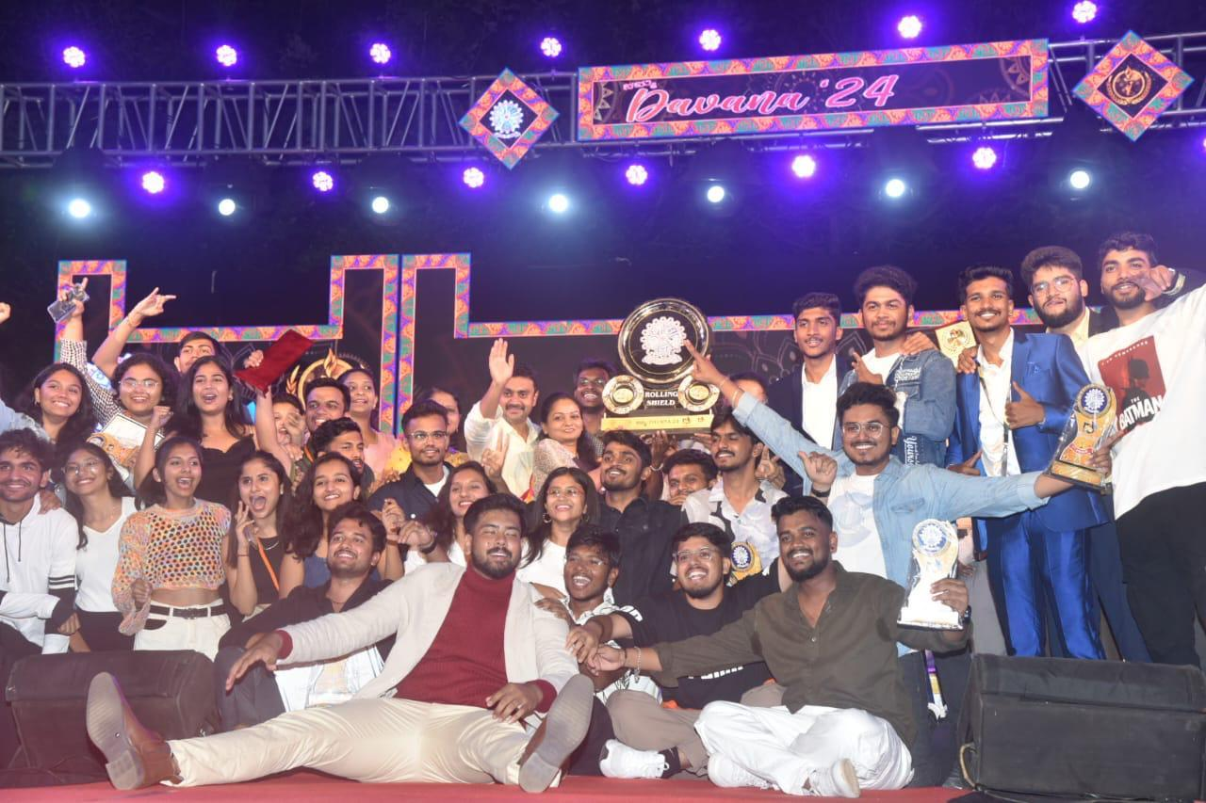  Students bagged 2nd Place- Runner Up in Davana -2024. | 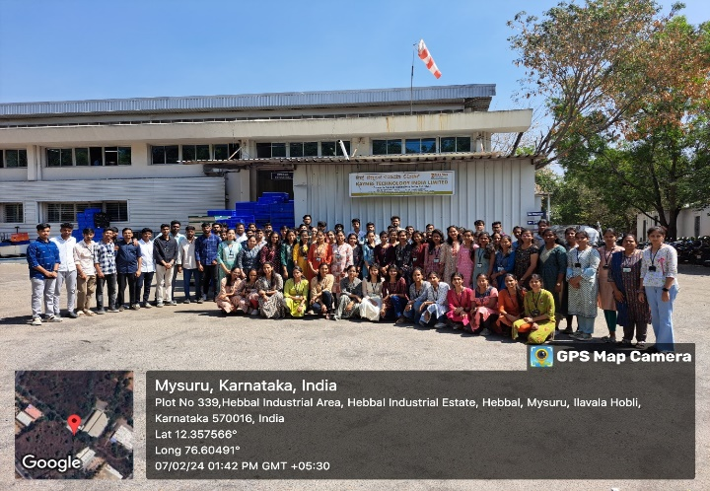Industrial visit to Kaynes Technology India Limited on 7th Feb 2024 with 87 students and 02 Professors.

Placements for the year 2023-2024
Number of offers received:73 53.78% Placement
Sl. No | Company Name | Total Number of Students Placed
1 | Accenture | 13
2 | TCS_Digital | 1
3 | TCS_Ninja | 6
4 | Destination Technology | 7
5 | Kasmo Technology | 4
6 | Pentagon Space | 5
7 | Sasken Technology | 3
8 | Talent Serve | 19
9 | Inube | 3
10 | SLK Software | 1
11 | RSL Technologies | 2
Total |  | 64

Art work by students

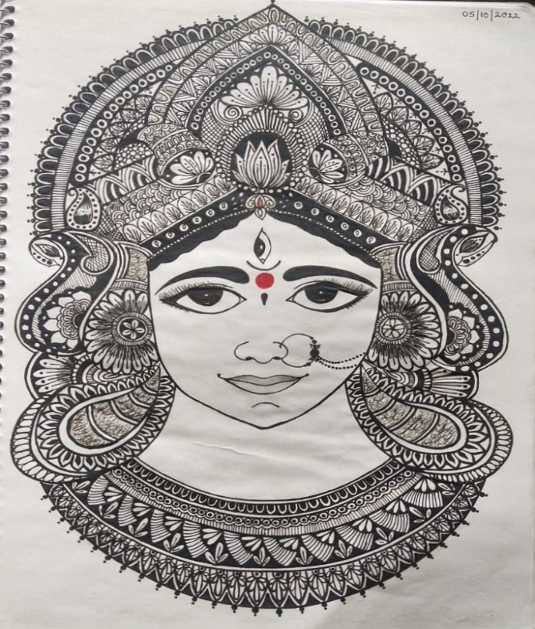 | 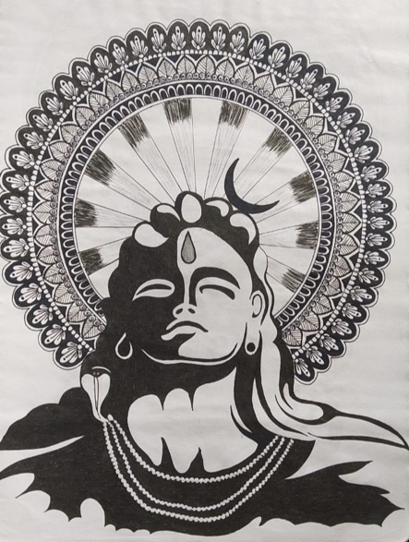
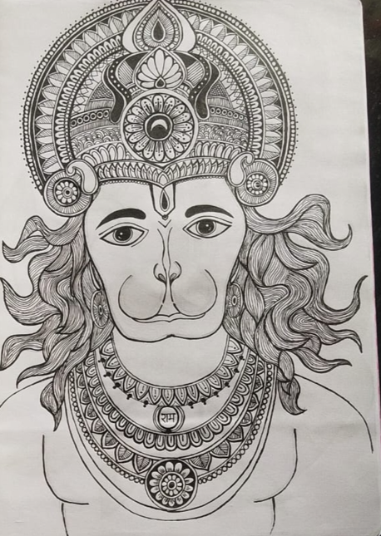 | 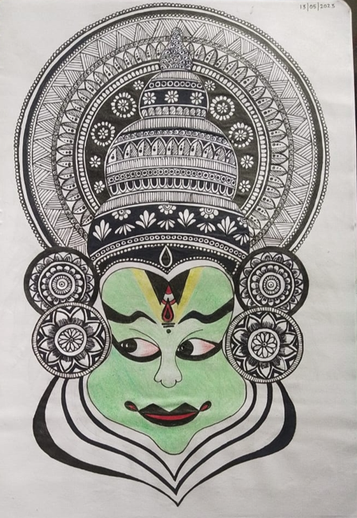
Name : Spoorthi G R
USN :4BD22IS155

Photography

 | 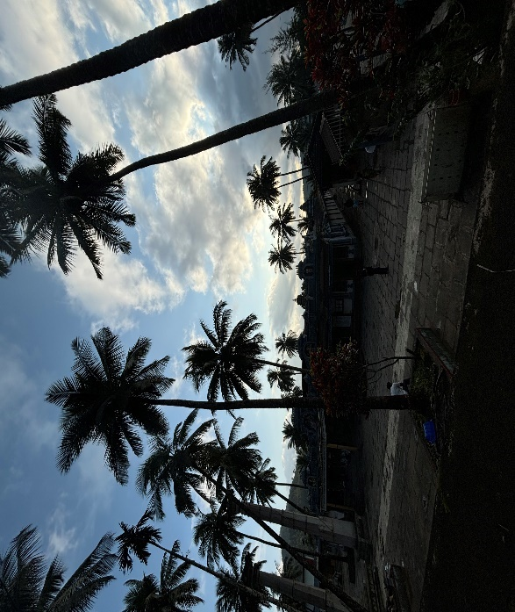
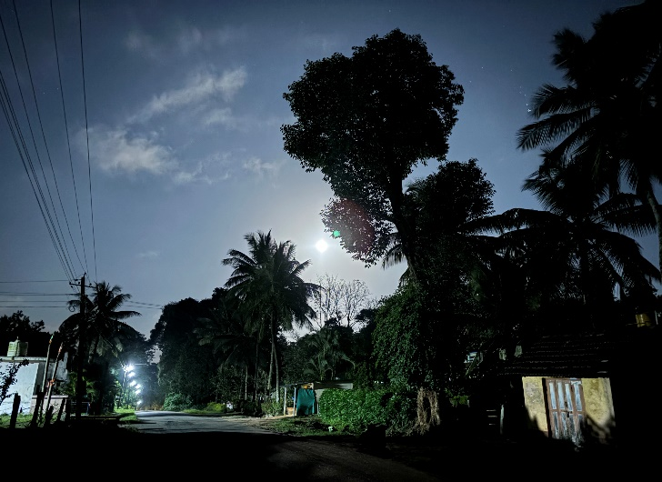 | 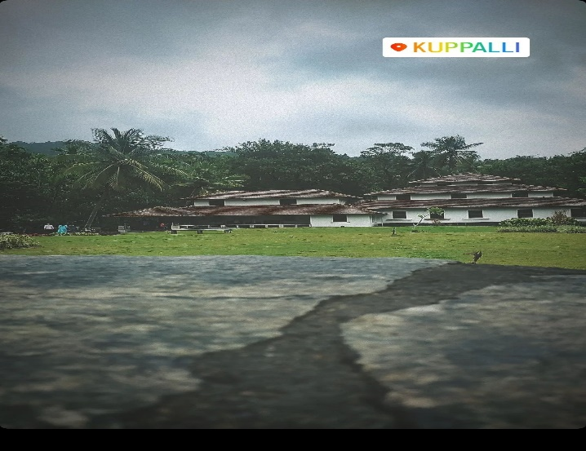
Name :Sumanth P Bellad
USN :4BD22IS161

Name : Spoorthi G R  USN :4BD22IS155 | Name : Manasa K  USN :4BD22IS

Glimpse of Info Arohana -2024

