Bapuji Educational Association (Regd.)
Bapuji Institute of Engineering and Technology

Davangere-04
(Affiliated to VTU Belagavi, Approved by AICTE, New Delhi)
Accredited by the NAAC with A Grade

BIETECH VOICE

News Letter
(For Private Circulation Only)

Department of Textile Technology

Aug 2023 –Dec 2023

Coordinators: Dr. K B Ravindra, Associate Professor Students: Ms. Varshini K S, 5th Semester

Mr. Nandish R S, Asst. Professor Mr. Prerana P, 8th semester

Volume: 04 Issue: 02
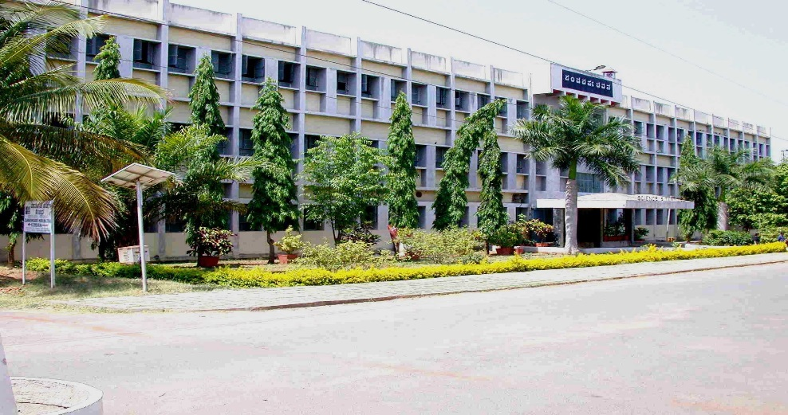

VISION
Department of Textile Technology
To be the center of excellence in textile education, besides serving the society by undertaking various innovative research, industry and society related activities.
MISSION
- To impart the basic science, engineering, textile, garment and fashion education for the growth and development of the students by providing effective teaching and learning processes
- To impart practical/research knowledge through industrial training and projects
- To empower the students with positive approach and presentation skills by conducting workshops and conference
- To inculcate ethical values of various virtues, which enable them to become successful textile technologists and good citizens of the nation.
FDP/WORKSHOP ATTENDED
- Shashank D R, Nandeesh R S and Nandikol S S, faculty members attended a 5 days FDP on “Data Analysis and Data Science 7-7-23 organized by IS & E , BIET
- Mr. Nandeesh R S, Shashank D R and S S Nandikol attended FDP Data analytics/Data management on 7/7/2023
- Dr. K B Ravindra, Dr. S M Chandrasakara, attended VTU-BOE meeting on 9/0/2023
- Mr. Nandeesh R S, Mr. Shashank D R and Ms. Deepashree, attended workshop on Artificial Intelligence on 18-08-23 in Placement hall, Dept. of Mechanical Engineering.
- All faculty members of the department attended a 2 days workshop on “Skills for quality research and publications on 8th & 9th Sept. 2023 in Placement cell seminar hall, Dept. of Mechanical Engineering.
- Mr. Shasahnk attended one day workshop on IOT on 1-12-24 orgaanised by Dept. of E & C

PUBLICATION
- Dr. Y N Dinesh, Prof, and Head completed NPTEL course on "Textile finishing on July-Oct. 2023 scoring 72%.

NOMINATION AND DEPUTATION OF FACULTY
- Dr. K B Ravindra and Dr. S M Chandrasekhara, are nominated as members, BOE, Textile/Silk Technology board
- Dr. S N Ramesh, was deputed to DKTE’s Textile and Engineering Institute, Ichalkaranji for an invited talk on 15th & 16th Dec 2023 for giving special lecture on the topic “modern approaches to Spinning”
CAMPUS PLACEMENT
- All 6th semester students undergone internship in various Textile industries from 11th August 2023 for a period of 3 – 4 weeks. List of companies and the no. of students undergone internship is given below.
Sl. No. | Company | No. of students
1 | Jockey India Pvt. Ltd, Bangalore | 8
2 | Aravind Mills, Bangalore | 4
3 | Aditya Birla, Bangalore | 6
4 | Shahi Exports, Bangalore | 5
5 | V M S Fabrics, Karur Industrial area, Davanagere | 3
6 | Shahi Exports, Bangalore | 3

Placement details for the year- 2022- 2023
Sl. No. | Company name | N. of students selected
1 | Shahi Exports Pvt Ltd. Bangalore | 05
2 | Aditya Birla, Bangalore. | 10
3 | Gokaldas Exports Ltd. Bangalore | 03
4 | Pret Interpret Clothing Pvt Ltd. Bangalore. | 03
5 | Tesco Bangalore. | 01
6 | Aravind mills Bangalore. | 14
7 | NTT Data information processing service Pvt. Ltd. | 01
8 | MANN + HUMMEL, Filter Pvt. Ltd. Bangalore. | 01
9 | Spintech Ltd, Bangalore | 04
 | Total | 38

EVENTS ORGANIZED
- Department organized one day workshop on “Recent trends in fabric formation and statistical quality control” on 01-02, Aug. 23. The resource person was Dr. J Hayavadana, Vice principal, University College of Technology, Osmania University, Hyderabad.
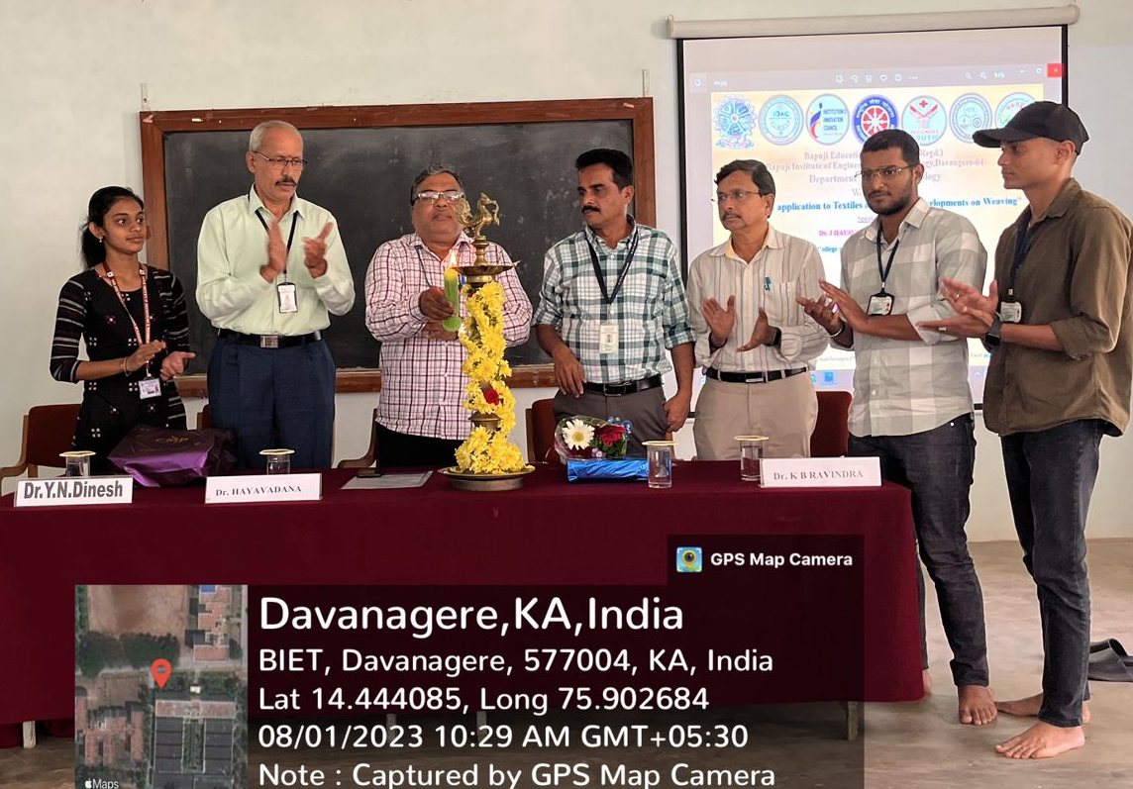
Workshop on recent trends - 01-08-23
- All 5th semester students attended special Lecture on “Biology for Engineers” delivered by Dr. Deepak Kumar
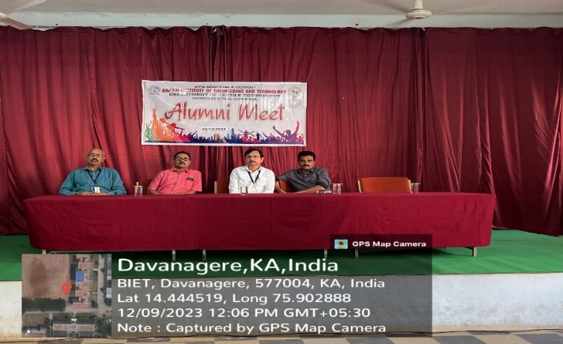
Special lecture on “Biology for Engineers”
- Students organized a Teachers’ day program for teachers of the department on 05-09-23
- Inauguration of Textile forum and welcome to 3rd semester students to the department was organized on 27-12-2023. Mr. Sunil A, a distinguished alumni, Head, Supply chain management, F H Nane Pvt. Ltd, Bangalore and Ms. Shrushti K Shenai, alumni, GET MANN + HUMMEL, Filter Pvt. Ltd. Bangalore were the chief guests for the function. Mr. Sunil gave a special lecture on “Scope and career opportunities for Textile graduates in different sectors”.
- A distinguished alumni, Mr. Shivaraj Vibhuthi, (1998 pass out) visited the department on 12-09-2023 and addressed the students.

- Infosys spring board meeting was conducted for 4th semester students on 20-07-2023.
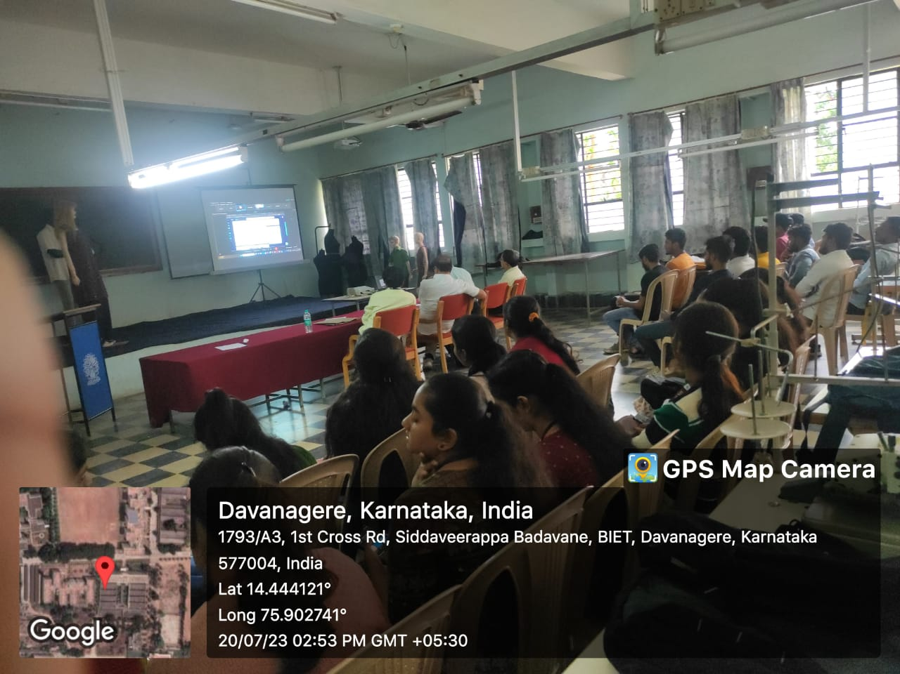
Address by Mr. Shivaraj Vibhuthi,
Infosys spring board meeting
- Ms. Malini S, an alumni, 2023 pass out batch, gave a guest lecture on “Industrial skills required in garment sector” on
- Department conducted a 3 day workshop for 5th semester students on RMI from 16th to 18th Jan 2024
- Department conducted a 3 day workshop for 3rd semester students on “Skill development” from 22nd to 25th Jan 2024.
- In connection with the add on course a one day special lecture session was organized on “ Practical Dimension of Production and Operations in the Apparel Industry” on 24-11-2023. The resource person was Dr. Selvadas, Garden city University, Bangalore.
- Induction program for 1st year students was conducted on 15-09-2023
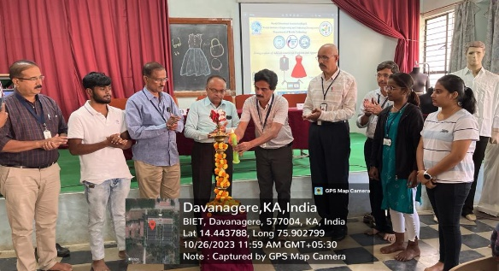
- Add-on course on “Fashion & Apparel Design” for 7th semester students conducted from 26/10/2023 to 13/12/2023. Recourse person was Mrs. Divya Rajiv
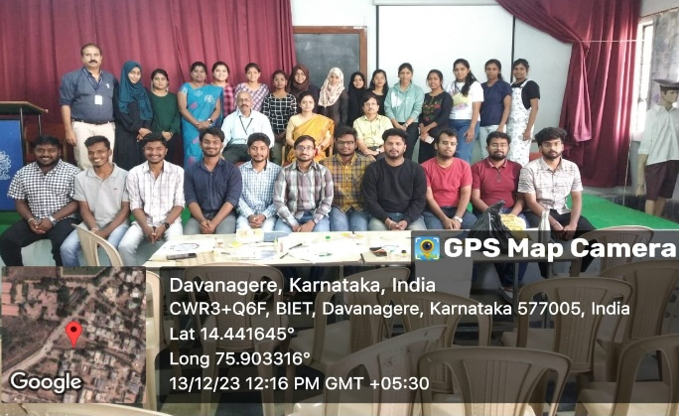
Inauguration of Add on course
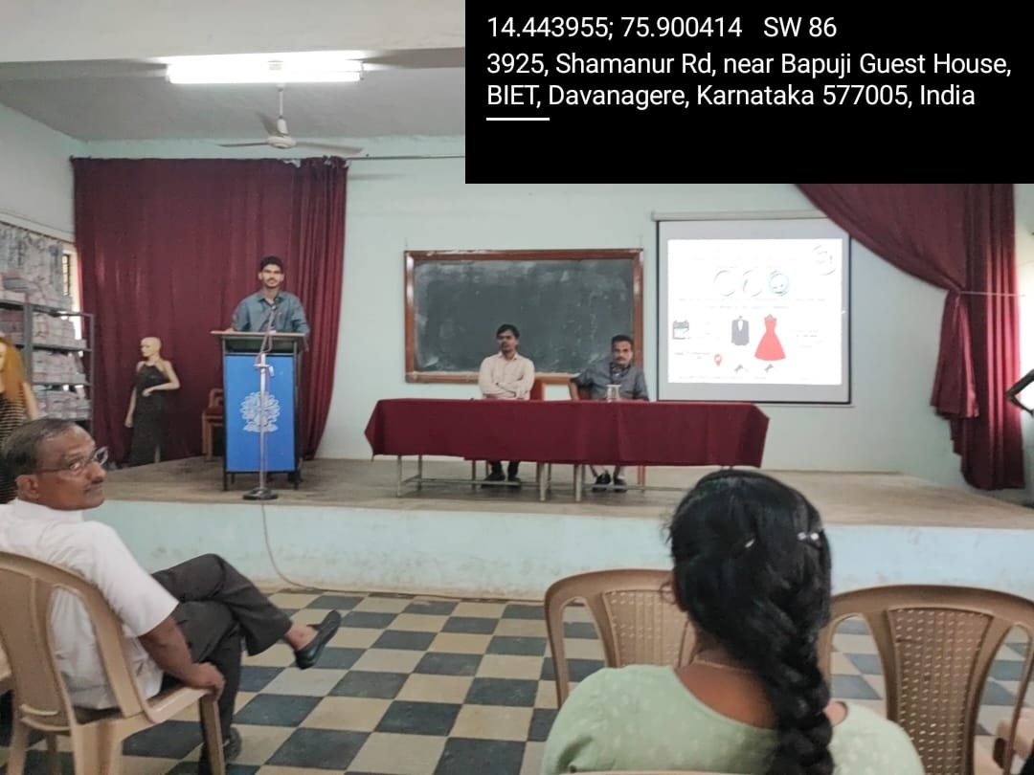
Valedictory of Add on Course
Lecture by Dr. Selvadas
- The department arranged an industrial visit to Shree Anjaneya Cotton Mills Ltd, Davangere on 07-12-2023.
ACHIEVEMENT OF STUDENTS
- The department received 09 Ranks from VTU, for the year 2022-23.
Sl. No. | Name | Rank
1 | Shrushti K Shenai | 1st
2 | Anusha G M | 2nd
3 | Sanjana K B | 3rd
4 | Malini S | 4th
5 | Ranjitha S S | 5th
6 | Rakshita Chand | 6th
7 | Shubhadevi M H | 8th
8 | Anitha V | 9th
9 | Chaitra N | 10th

Mr. Shrushti Shenai 1st Rank
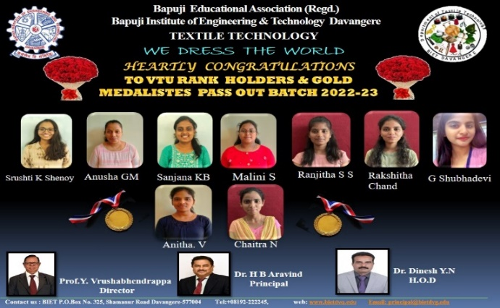
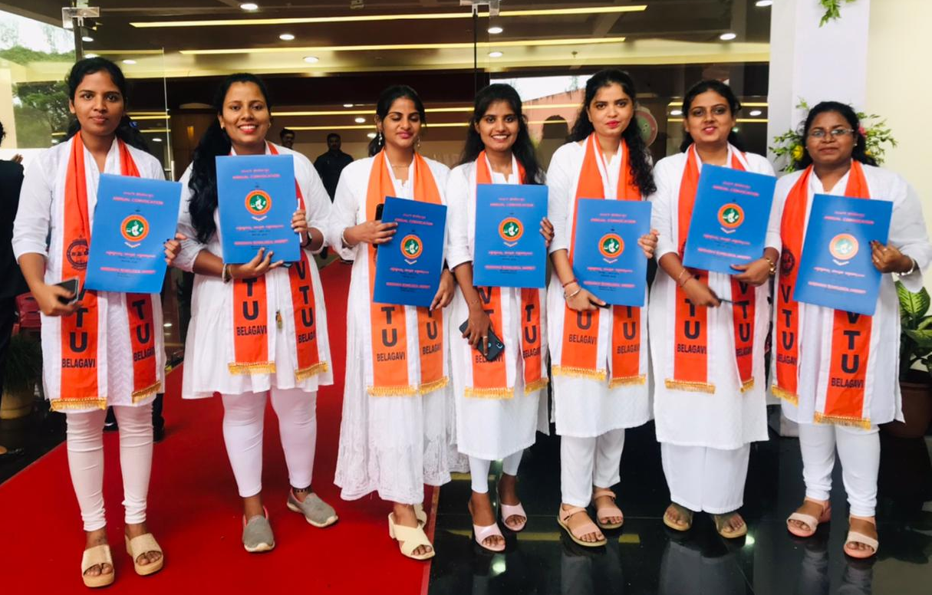
VTU rank holders 2022-23
- Mr. Prajwal J P, and Ms. Prerana P of 7th semester cleared NPTEL course on “Consumer Psychology “on Sept. 2023.
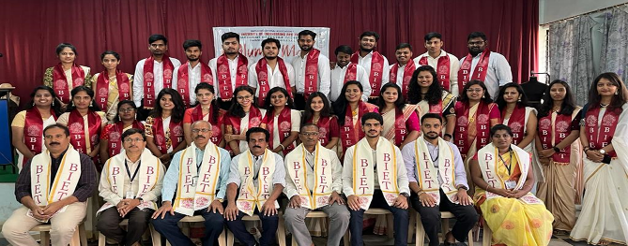
- An alumni meet & graduation day celebration was conducted for 2023 batch pass out students was conducted on 21-10-2023.

- A photo session was organized for Outgoing batch 2022-23 students

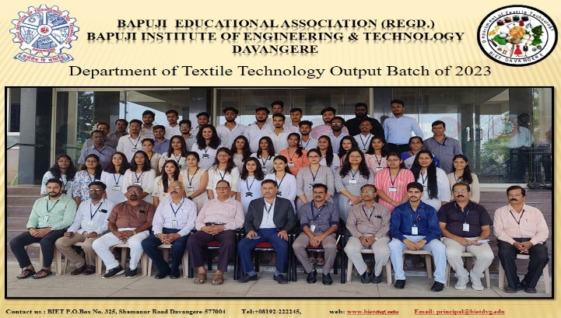
Outgoing batch of 2023 pass out students

Compiled by
Dr. K B Ravindra,
Associate Professor,
Dept. of Textile Technology
