 **Bapuji Educational Association (Regd.)**

**Bapuji Institute of Engineering and Technology**

## Davangere-04

(Affiliated to VTU Belagavi, Approved by AICTE, New Delhi)

**Accredited by the NAAC with A Grade**

BIETECH VOICE

# News Letter

**(For Private Circulation Only)**

# Department of Textile Technology

# Aug 2024 –Dec 2024

# Coordinators: Dr. K B Ravindra, Associate Professor Students: Ms. Varshini K S, 7th Semester

# Mr. Nandeesh R S, Asst. Professor Ms. Prerana P, 8th semester

# Volume: 04 Issue: 02

# DSCN0633

# 

**VISION**

**Department of Textile Technology**

To be the center of excellence in textile education, besides serving the society by undertaking various innovative research, industry and society related activities**.**

**MISSION**

* To impart the basic science, engineering, textile, garment and fashion education for the growth and development of the students by providing effective teaching and learning processes
* To impart practical/research knowledge through industrial training and projects
* To empower the students with positive approach and presentation skills by conducting workshops and conference
* To inculcate ethical values of various virtues, which enable them to become successful textile technologists and good citizens of the nation.

**FDP/WORKSHOP ATTENDED**

1. Dr. Dinesh Y N, Dr. S M Chandrasekhara and Kavya L faculty members attended the English communication workshop on
2. Dr. K B Ravindra and Mr. Nandeesh attended seminar on “Research project proposal submissions” at Biotech seminar hall on 21-10-24.
3. Mr. Shashank attended training program on “VTU Consortium e-resources for library professionals for faculty and research scholars” held at UBDT, Davangere on 23-10-24
4. Following research scholars registered for Ph. D under Dr. Y N Dinesh and Dr. S M Chandrasekhara

|  |  |  |  |
| --- | --- | --- | --- |
| **Sl. No.** | **Name of guide Guide** | **Name of Co-guide** | **Name research scholar** |
| 1 | Dr. Y N Dinesh | -- | Kavya S |
| 2 | Dr. S M Chadrasekhara | -- | Adalarasu N |
| 3 | Dr. S M Chadrasekhara Dr. Y N Dinesh | Dr. Y N Dinesh | Mohana Priya R |

**PUBLICATION**

1. A review paper titled “Antimicrobial properties of some natural dye – A review”, authored by K B Ravindra, Y N Dinesh and S M Chandrasekhara was published in Trends in Textile Engineering & Fashion Technology, 10(3).2024

**NOMINATION AND DEPUTATION OF FACULTY**

1. Dr. Dinesh Y N attended BOE meeting on 14-10-24 held at VTU, Belagavi
2. Mrs. Kavya L, a new faculty member is reported for the duty as Assistant Professor, in Department of Textile Technology on 9-9-24.

**CAMPUS PLACEMENT**

1. Twenty final year students got selected by various Textile/Garment industries in the campus interview held at the Institute placement cell and four students pursued their higher studies. The department achieved 76% placement.

|  |  |  |  |
| --- | --- | --- | --- |
| **Sl.NO** | **Company** | **On-campus/off-campus** | **No of Student** |
|  | Shahi Exports Pvt. Ltd. Bangalore | On-campus | 03 |
|  | Gokaldas Exports Ltd. Bangalore | off-campus | 03 |
|  | Avery Dennison India Pvt, Ltd | off-campus | 02 |
|  | Aravind mills Bangalore | off-campus | 05 |
|  | Vishwaa Apparels | off-campus | 02 |
|  | Laguna Clothing Pvt. Ltd. | off-campus | 02 |
|  | Wonder blues Apparels Pvt. Ltd | off-campus | 01 |
|  | Positex Pvt. Ltd, Bangalore | off-campus | 01 |
|  | Intratech Pvt.Ltd, Bangalore | off-campus | 01 |

**EVENTS ORGANIZED**

1. Students participated in “Drug free campus” event organized by Institute on 21-8-24

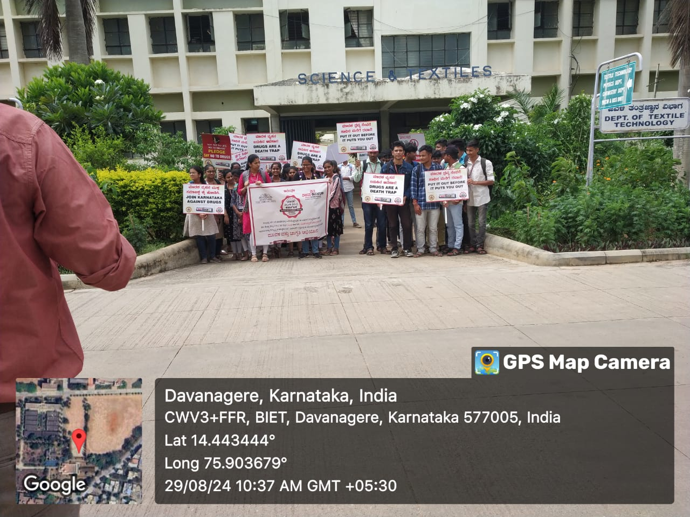

**Drug free campus**

1. An alumni meet was conducted for 2024 output batch on 28-9-24 Saturday in Garment laboratory. Er. Vijayendra Babu, Senior Vice President –Operations, Grasim Industries, Kumarapatnam, Harihara was the Chief Guest and distributed the Degree Certificates to the 2024 output batch students. On the occasion he also spoke on "Career growth and employment opportunities in Fibers manufacturing industry".

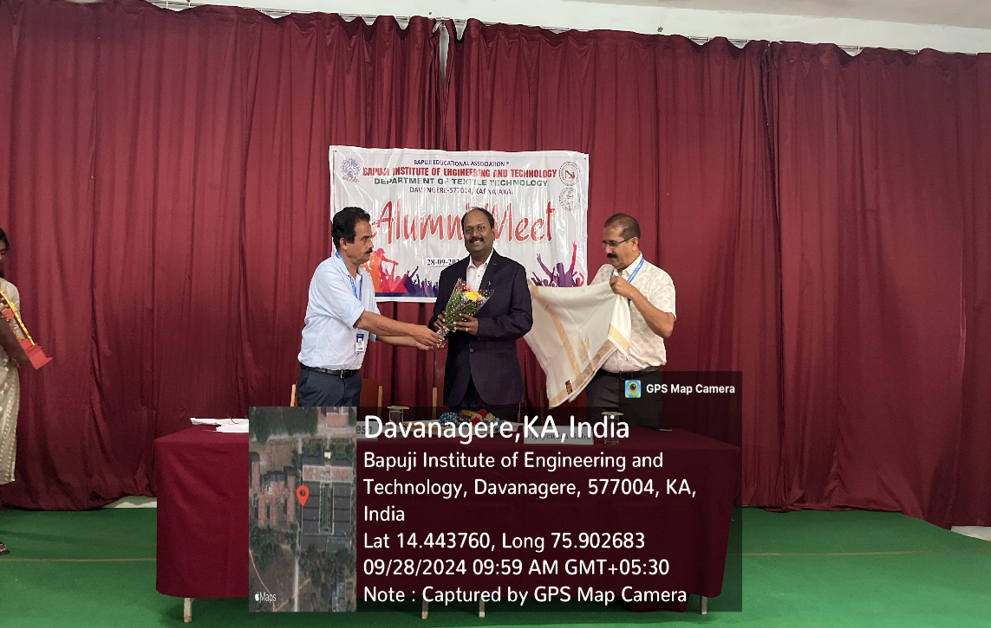

**Visit by Er. Vijayendra Babu**

1. Third semester students visit to Tarlabalu Krishi Vignana Kendra, Davangere on 01-10-2024 in connection with SCR.

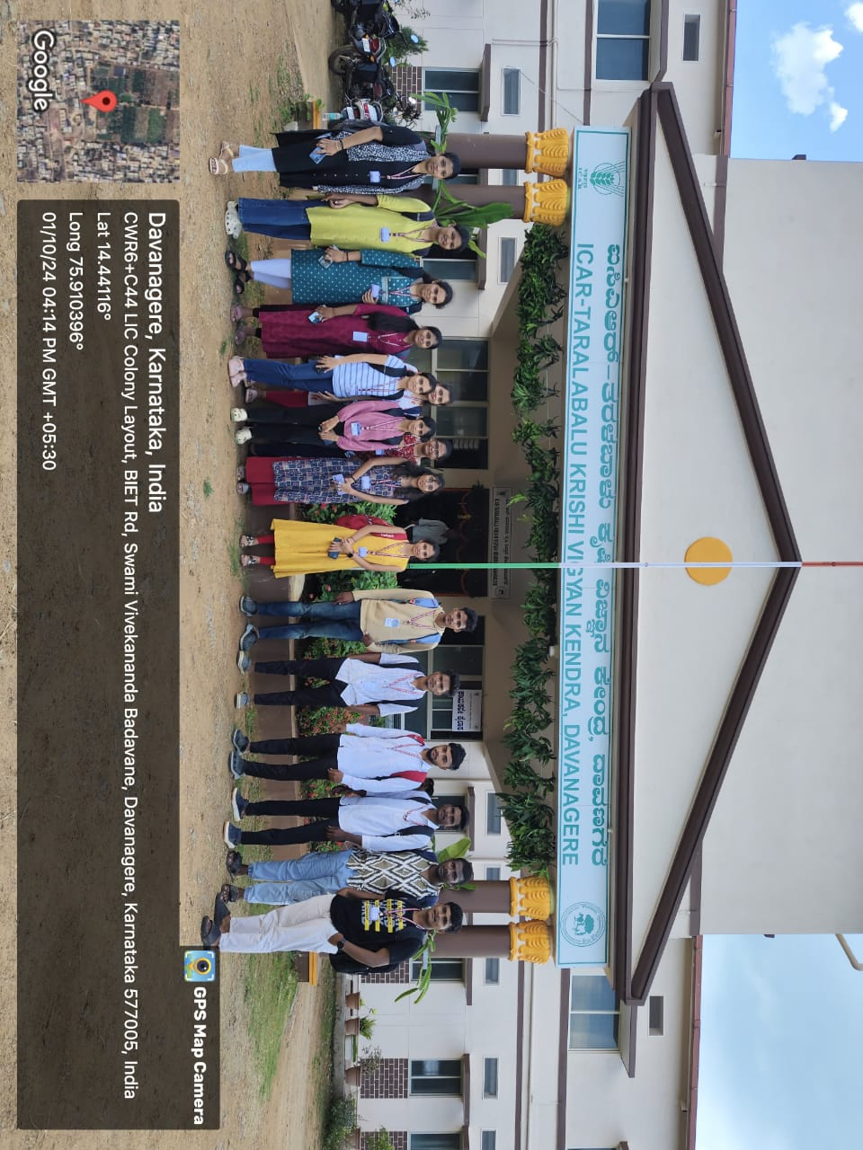

**Tarlabalu Krishi Vignana Kendra Davangere**

1. Veda C J, an Alumnus (2015 output batch) visited the department on 26-10-2024 and delivered a lecture on “Higher studies and supply chain management”. She also shared her study and working experiences with students.
2. A farewell function was arranged for Dr. K B Ravindra on his retirement from his duties on 30-9-24 at 4.00 PM in Garment lab.

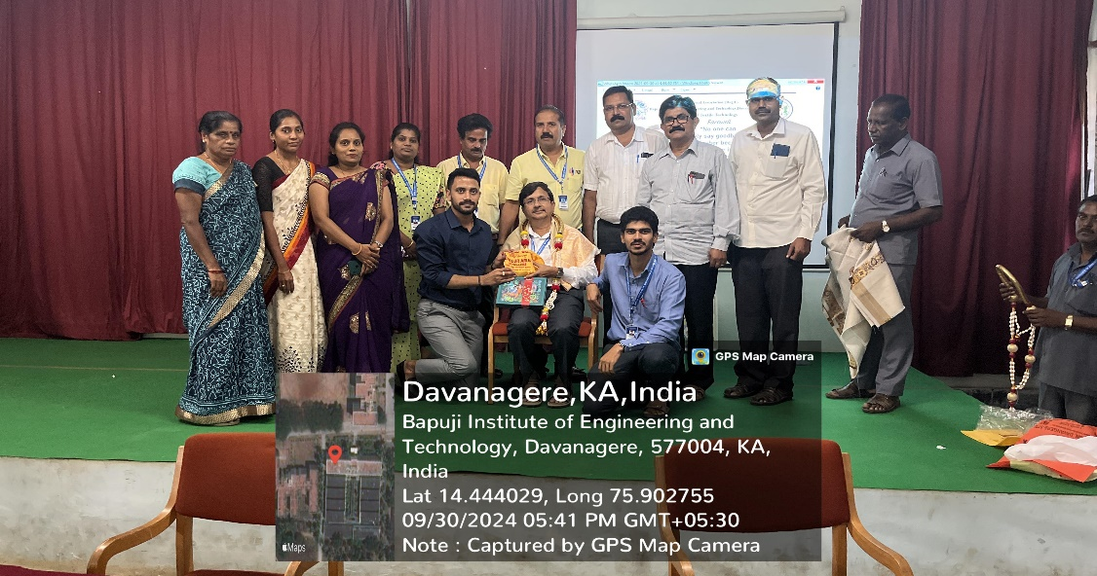

**Farewell to Dr. K B Ravindra**

1. Inauguration of Textile forum activities for the year 2024-25 was arranged on 9-10-24 in Garment lab. Ms. Dhanalakshmi (an Alumnus) PPC and Marketing, Shahi Exports P Ltd,. Shimoga was the chief guest and she spoke about the responsibilities of students in shaping their future career.

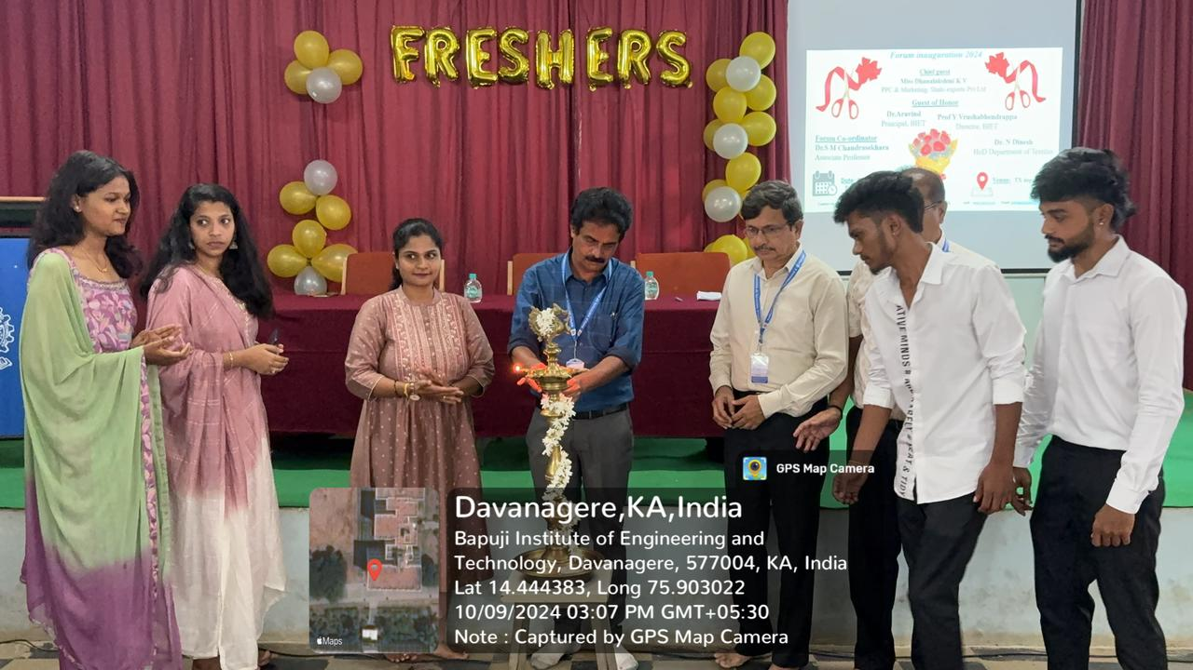

**Inauguration of Textile forum activities**

1. In association with VTU - UHV cell, the department organized online lecture session VI “Embedding human values into engineering education” for 1st year Textile, Chemical and Mechanical students on ton 16-10-24 in Garment lab.
2. Third semester students accompanied by Dr. S M Chandrasekhara visited Silk Filature unit, Tholahunse, Davangere on 23-10-24.
3. Dr. K B Ravindra is deputed to visit CHARAKA MAHILA VIVIDODDESHA KAIGARIKA SAHAKARA SANGHA NI, Bheemanakone, Sagar Tq. Shimoga Dt on 22-11-2024 to work as a technical expert. The department has agreed to support the organisation on consultancy work basis and help them set up the textile testing laboratory.
4. As part of Heritage walk 3rd semester students visited Harihareshwara temple in Harihara on 5-12-24.
5. As part of NSS & AICTE activity 7th semester students visited Doggalli organic Jaggery industry on 15-12-24.

**ACHIEVEMENT OF STUDENTS**

1. Deepak Dewasi, Manikant Y B, Varshini K S and Sritej K of 7th semester participated in national level Quiz competitions held in Kasturi Sreenivasan Art Gallery, Coimbatore, Tamilnadu on 14- 9-24

**Compiled by**

Dr. K B Ravindra,

Associate Professor,

Dept. of Textile Technology

